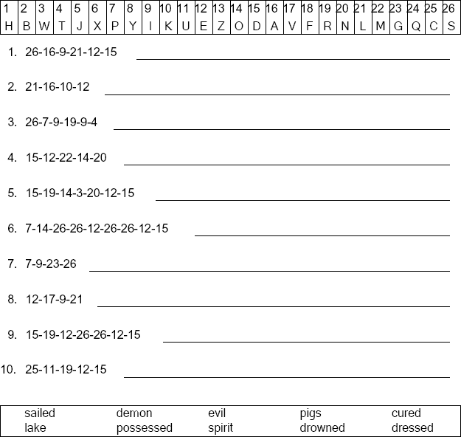
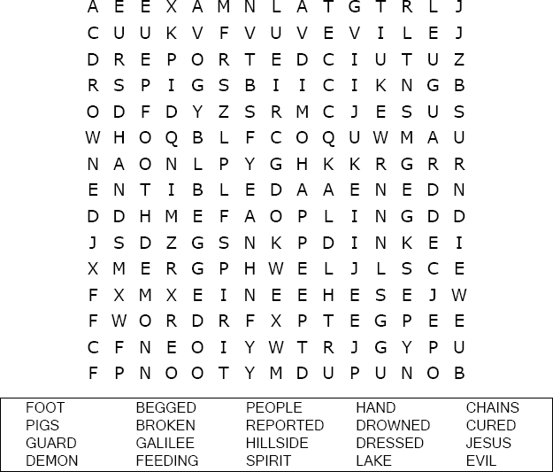

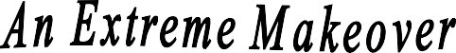

Luke 8:35
Copyright © Sermons4Kids, Inc. May be reproduced for Ministry Use
Your Church Name Here
Anytown, USA
Children’s Worship Bulletin

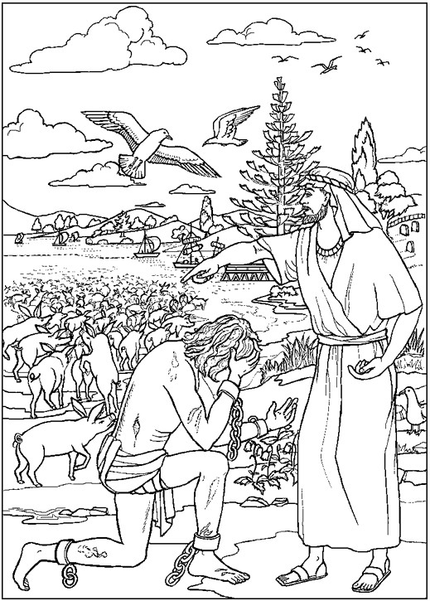

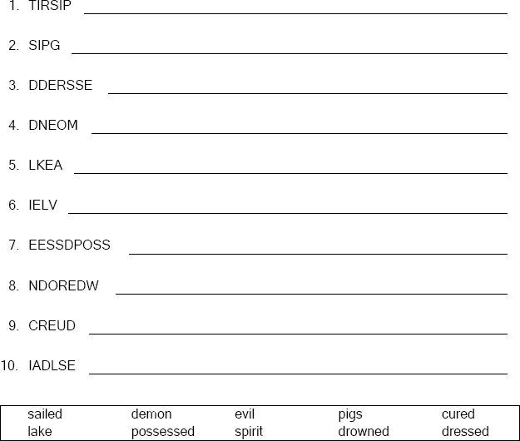

Unscramble the letters and write the word correctly .
Copyright © ABDA Acts - Arts and Publishing Used by permission.

