Crossword Puzzle

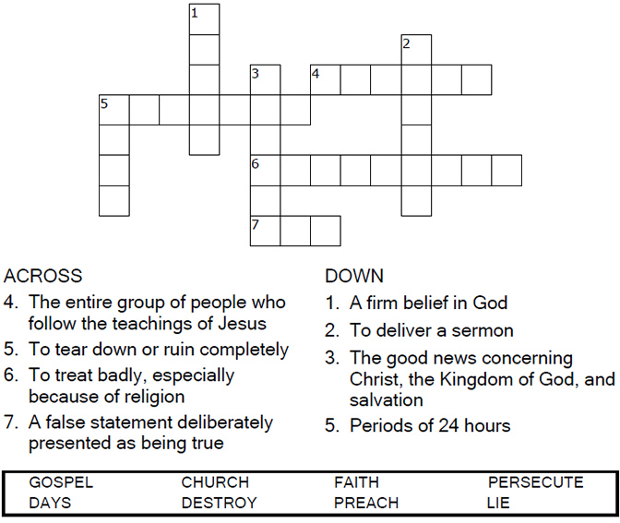
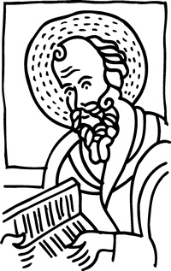
Copyright © Sermons4Kids, Inc.
May be reproduced for Ministry Use

Children’s Worship Bulletin



Galatians 1:11-24

Word Search

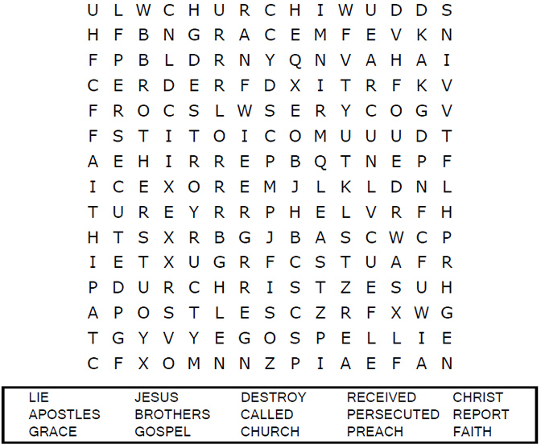
Your Church Name Here
Anytown, USA

Decoder Puzzle
Each number represents a letter of the alphabet.
Substitute the correct letter for the numbers
to reveal the coded words.

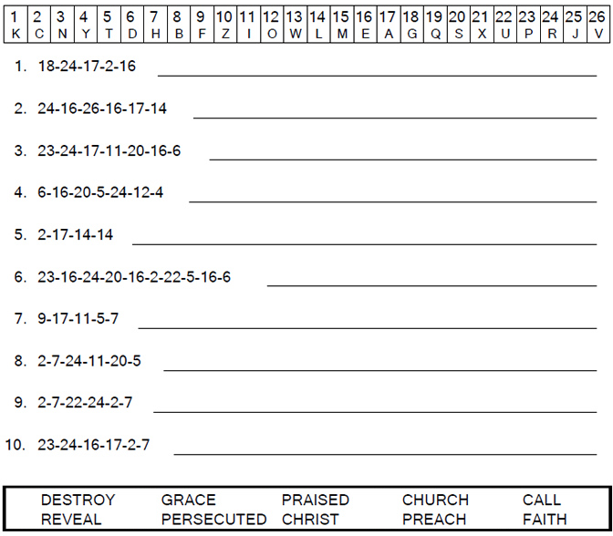
From Thru-the-Bible Coloring Pages for Ages 4-8. © 1986,1988 Standard Publishing.
Used by permission. Reproducible Coloring Books may be purchased from
Standard Publishing, www.standardpub.com, 1-800-543-1301.
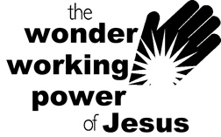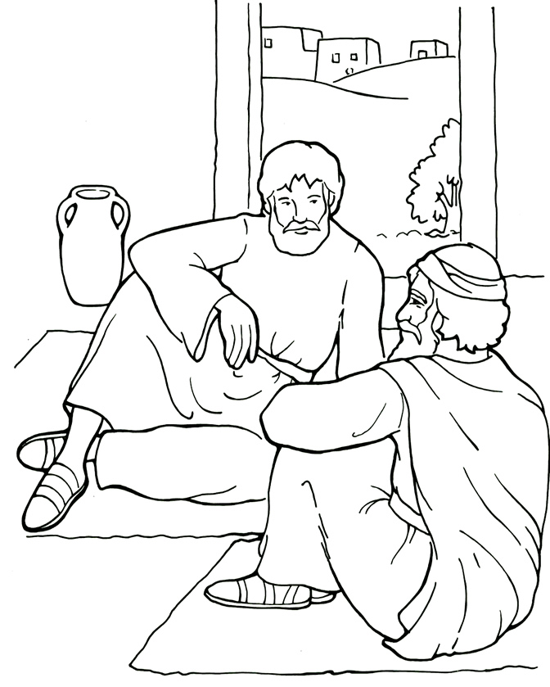

Coloring Page
Paul learned that Jesus is God’s Son.

