Crossword Puzzle

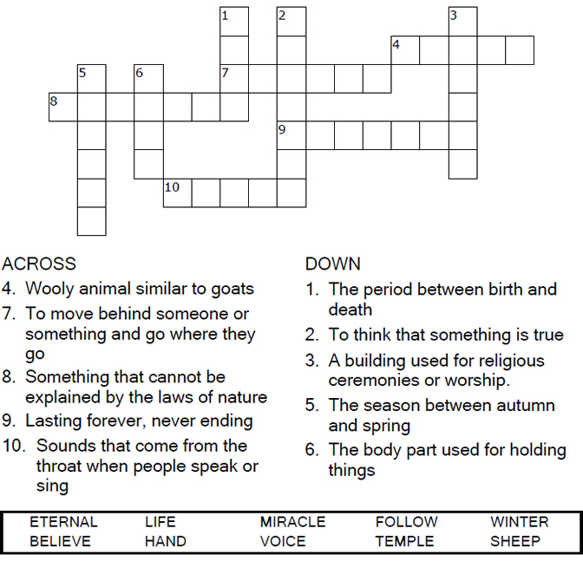

Copyright © Sermons4Kids, Inc.
May be reproduced for Ministry Use

Children’s Worship Bulletin



John 10:22-30

Word Search

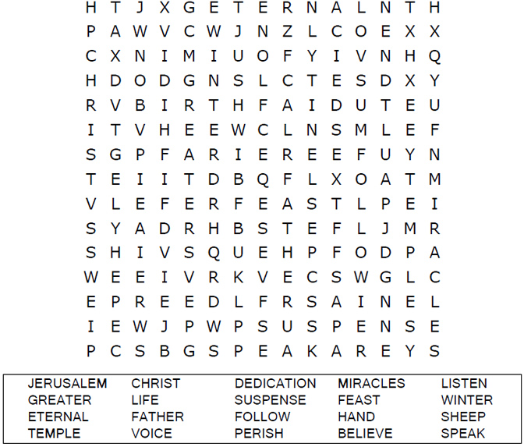
Your Church Name Here
Anytown, USA

Dot to Dot
Connect the dots to complete the picture.

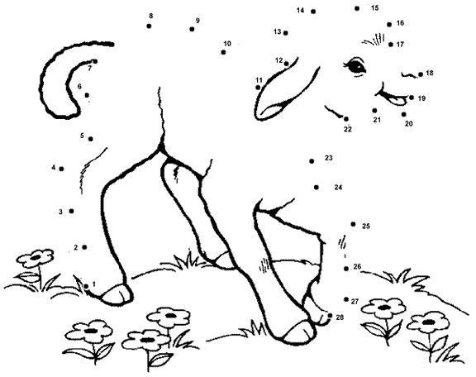



Color Me!

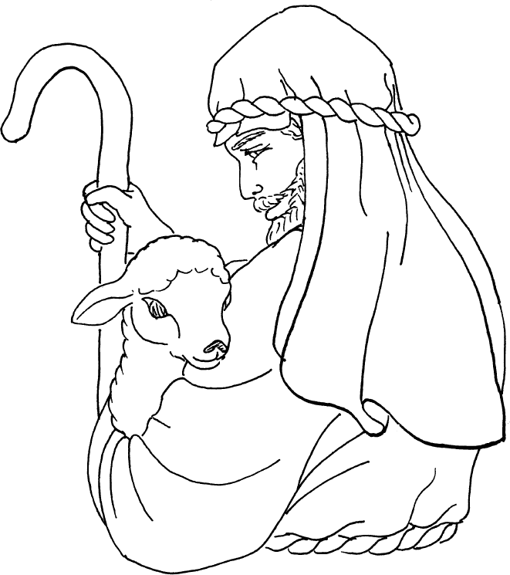

My sheep listen to my voice; I know them, and they follow me.
I give them eternal life, and they shall never perish;
no one can snatch them out of my hand.
John 10:27-28 (NIV)

