Crossword puzzle

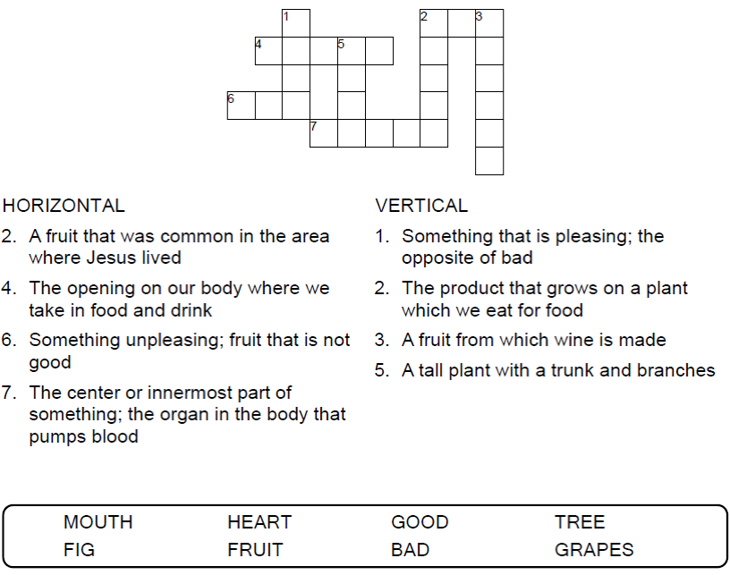


Copyright © Sermons4Kids, Inc.
May be reproduced for Ministry Use

Children’s Worship Bulletin



Luke 6:43-45

Word search Puzzle

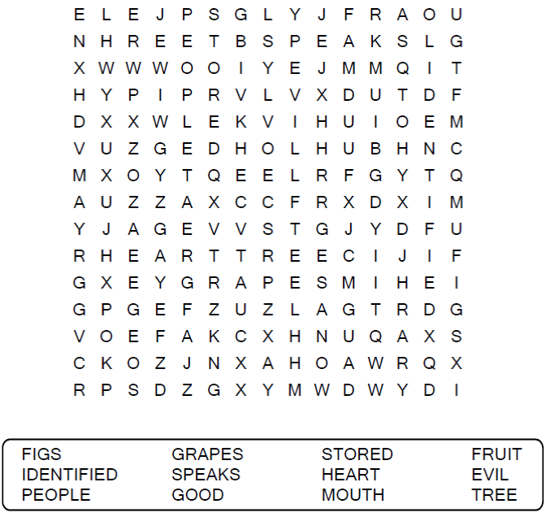
Your Church Name Here
Anytown, Anywhere
Color me!

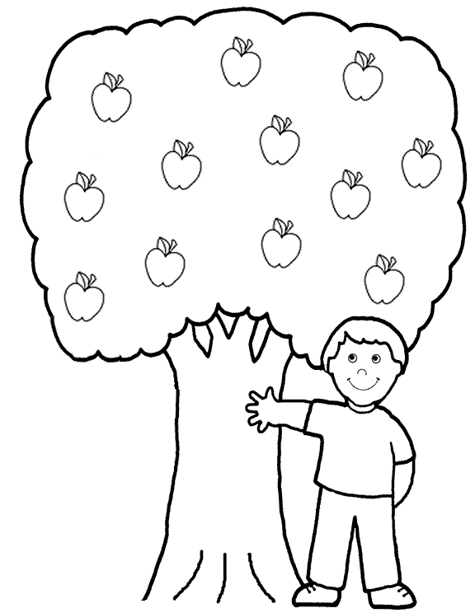
God wants us to bear good fruit!
Fill in the blanks
The answers in this activity can be found in Luke 6:43-45.
