Crossword Puzzle

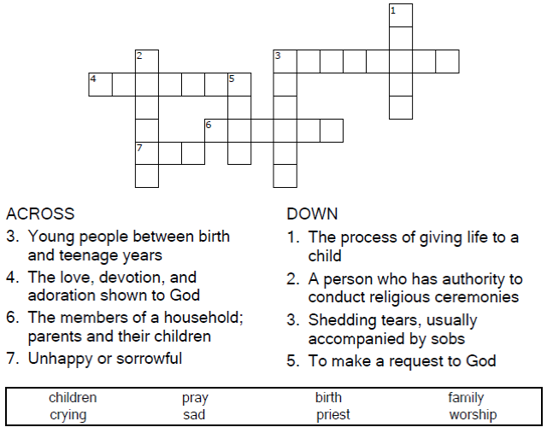



Copyright © Sermons4Kids, Inc.
May be reproduced for Ministry Use
Children’s Worship Bulletin



1 Samuel 1:4-20

Word Search Puzzle

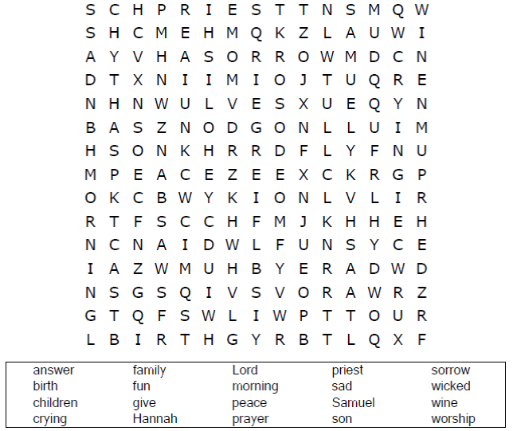

Your Church Name Here
Anytown, Anywhere

Coloring Page

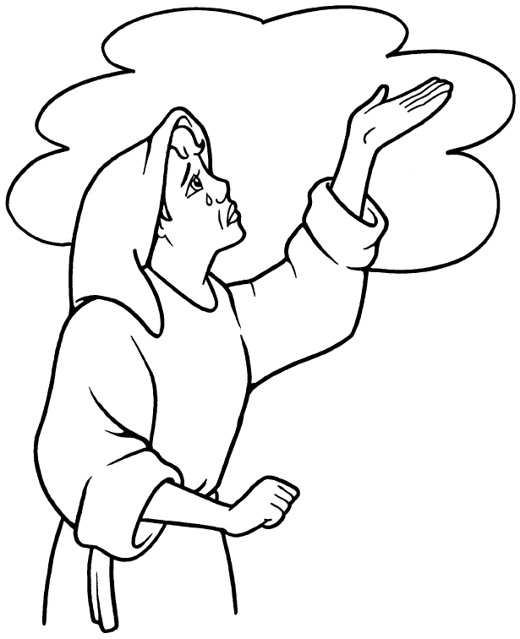
Hannah wept and prayed to the LORD.
1 Samuel 1:10

Copyright © CalvaryCurriculum.com
Used by Permission

Multiple Choice Quiz
Choose the word that best matches the definition.

