Crossword Puzzle

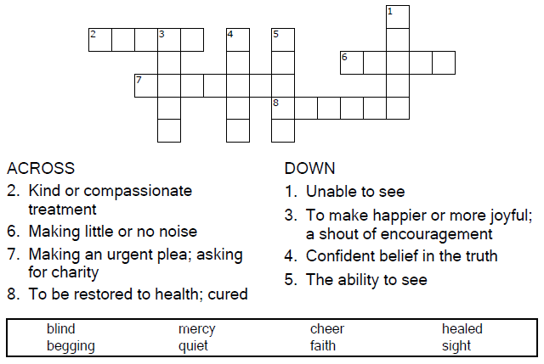

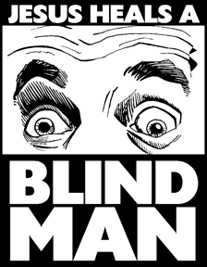

Copyright © Sermons4Kids, Inc.
May be reproduced for Ministry Use
Children’s Worship Bulletin



Mark 10:46-52

Word Search Puzzle

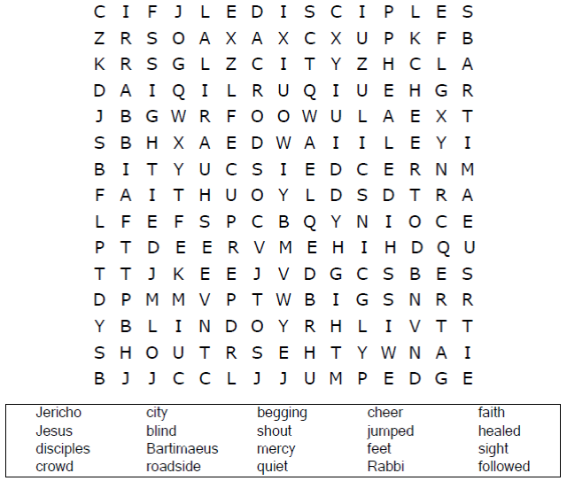
Church Name
Address
City

Coloring Page

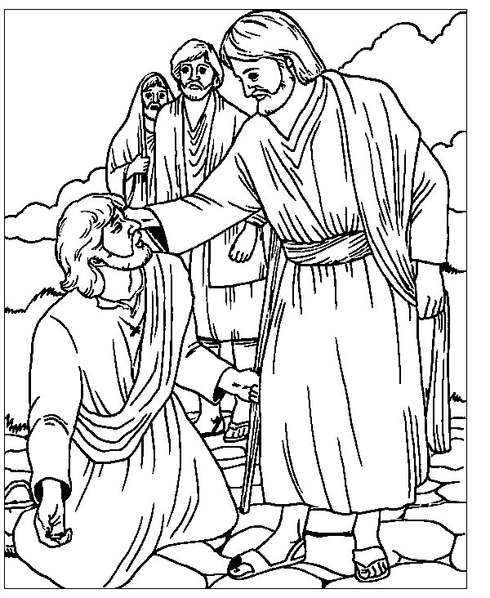

Jesus Heals a Blind Man
Mark 10:46-51

From BibleStoryCard Learning System™
Coloring Book © 1996 Wesleyan Publishing House
http://www.parable.com/wph/group_1052.htm

ABC Order

Write the words from the word bank at the bottom
of the puzzle in the blanks in A B C order.
