Crossword Puzzle

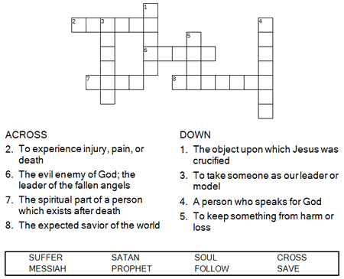

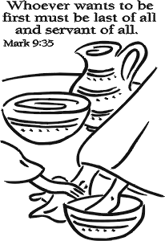

Copyright © Sermons4Kids, Inc.
May be reproduced for Ministry Use

Children’s Worship Bulletin



Mark 9:30-37

Word Search Puzzle

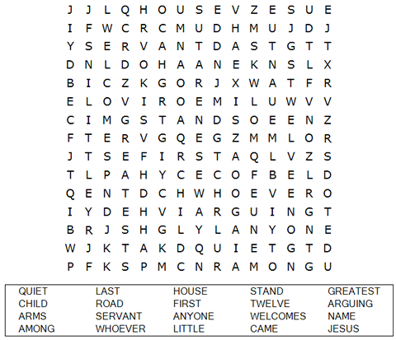

Your Church Name Here
Anytown, USA

Coloring Page

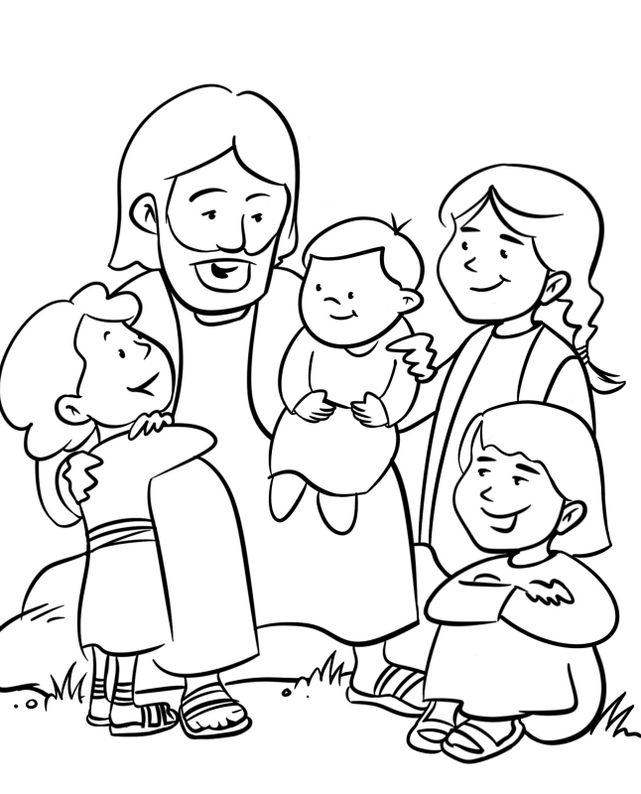

Jesus and the Children

From Thru-the-Bible Coloring Pages © 1986,1988 Standard Publishing.
Used by permission. Reproducible Coloring Books may be purchased from
Standard Publishing, www.standardpub.com, 1-800-323-7543.

Decoder Puzzle
Each number represents a letter of the alphabet. Substitute the correct letter for the numbers
to reveal the coded words.

