Crossword Puzzle

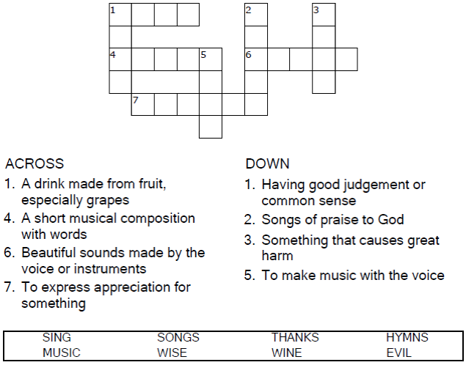


Copyright © Sermons4Kids, Inc.
May be reproduced for Ministry Use
Children’s Worship Bulletin



Ephesians 5:15-20

Word Search Puzzle

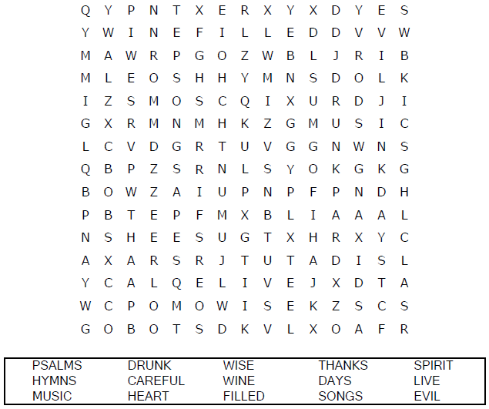
Church Name
Address
City

Coloring Page


From Thru-the-Bible Coloring Pages for Ages 4-8. © 1986,1988 Standard Publishing.
Used by permission. Reproducible Coloring Books may be purchased from
Standard Publishing, www.standardpub.com, 1-800-543-1301.

Maze Puzzle

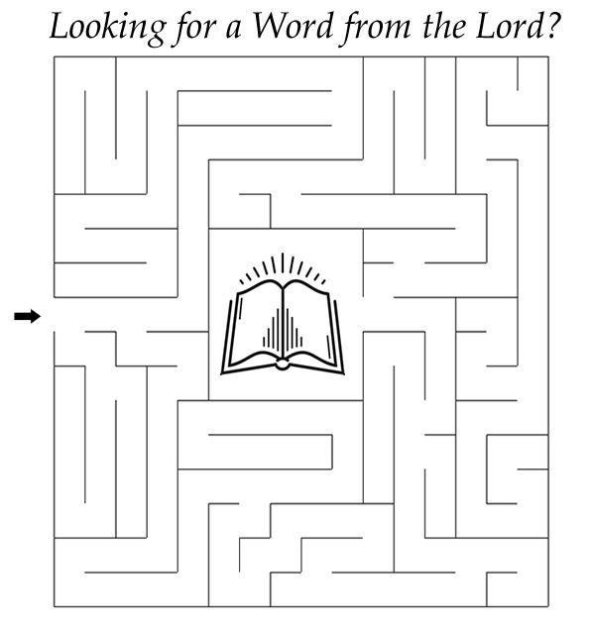

Be very careful, then, how you live — not as unwise
but as wise, making the most of every opportunity,
because the days are evil.
Ephesians 5:15-16 (NIV)

