Crossword Puzzle

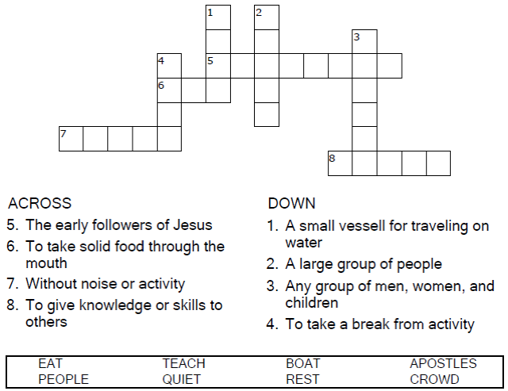
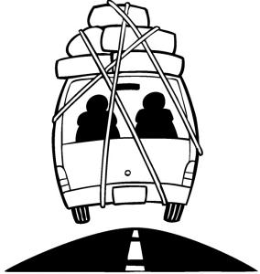

Copyright © Sermons4Kids, Inc.
May be reproduced for Ministry Use
Children’s Worship Bulletin



Mark 6:30-34

Word Search Puzzle

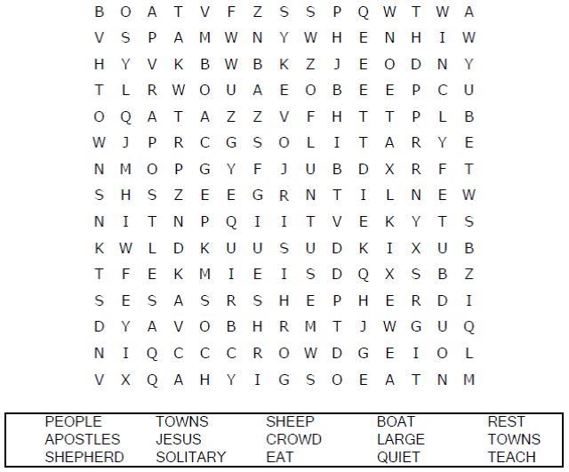

Your Church Name
Any Town, Anywhere

Coloring Page

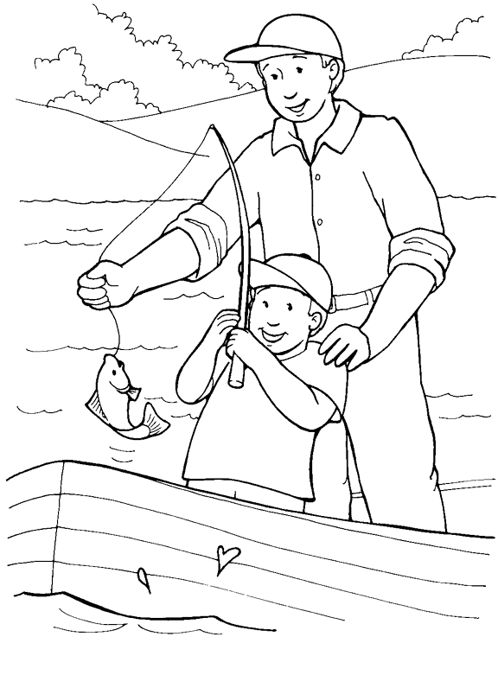
"Come with me by yourselves to a quiet place
and get some rest."
Mark 6:31
From Thru-the-Bible Coloring Pages © 1986,1988 Standard Publishing.
Used by permission. Reproducible Coloring Books may be purchased
from Standard Publishing, www.standardpub.com, 1-800-323-7543.

Decoder Puzzle

