Crossword Puzzle

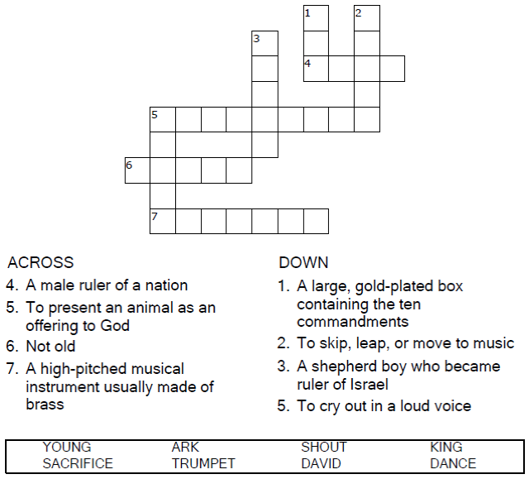


Copyright © Sermons4Kids, Inc.
May be reproduced for Ministry Use
Children’s Worship Bulletin



2 Samuel 6:1-5, 12-19

Word Search Puzzle

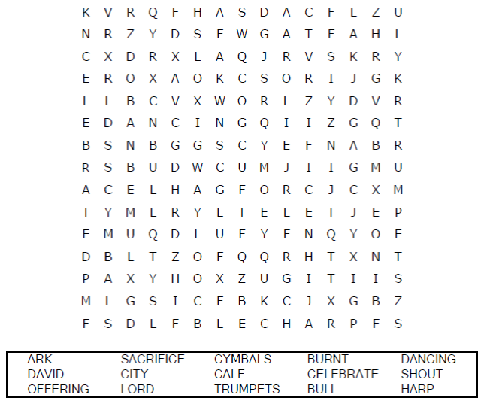

Your Church Name
Any Town, Anywhere

Coloring Page

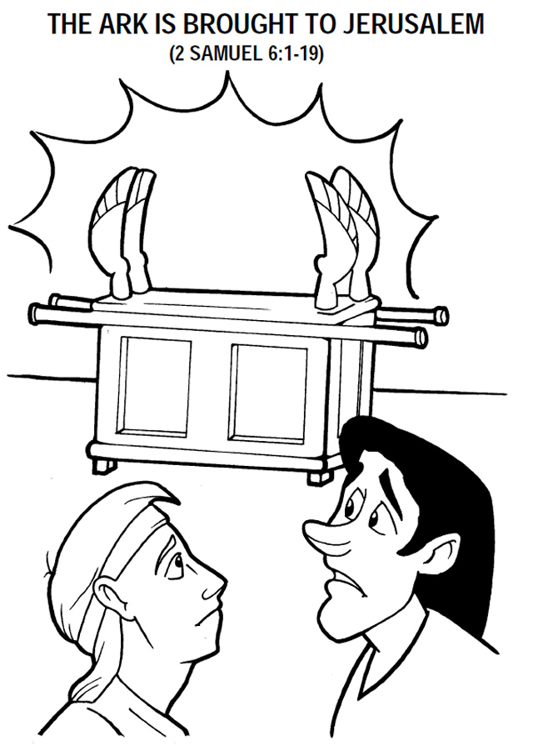
Copyright © CalvaryCurriculum.com
Used by Permission

Decoder Puzzle

Each number represents a letter of the alphabet. Substitute the
correct letter for the numbers to reveal the coded words.

