Crossword Puzzle

He Has Chosen Us

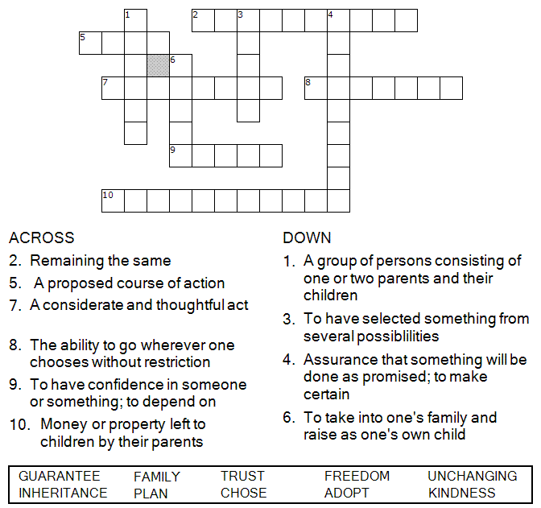



Copyright © Sermons4Kids, Inc.
May be reproduced for Ministry Use

Children’s Worship Bulletin



Ephesians 1:3-14

Word Search Puzzle

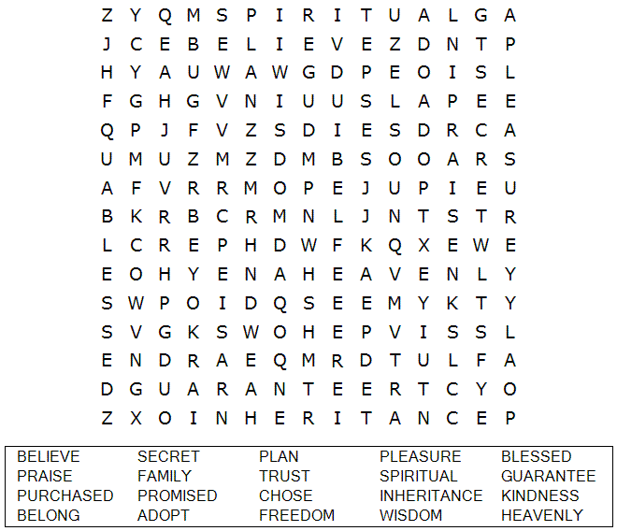

Your Church Name Here
Anytown, USA

Coloring Page

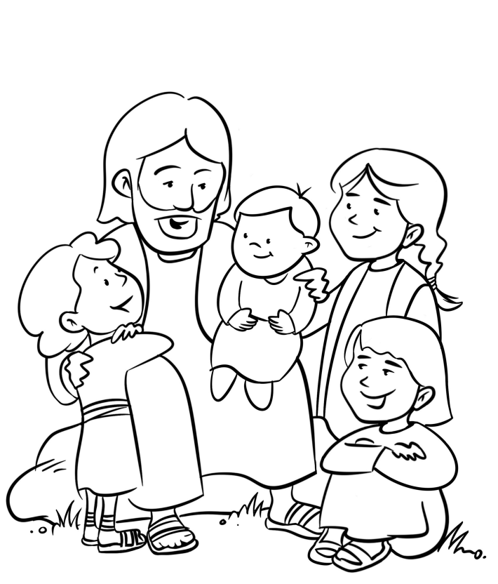
Jesus and the Children

Decoder Puzzle
Each number represents a letter of the alphabet. Substitute the correct letter for the numbers to reveal the coded words.

