Crossword Puzzle

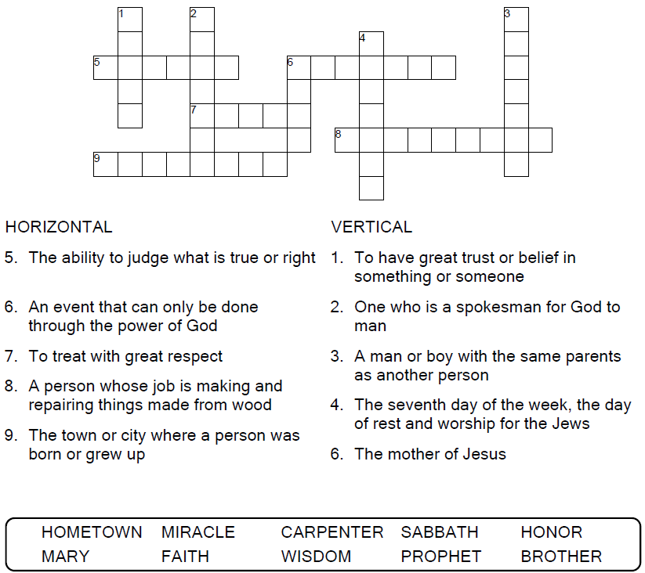
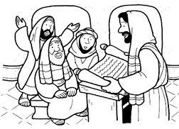

Copyright © Sermons4Kids, Inc.
May be reproduced for Ministry Use
Children’s Worship Bulletin



Mark 6:1-6

Word Search Puzzle

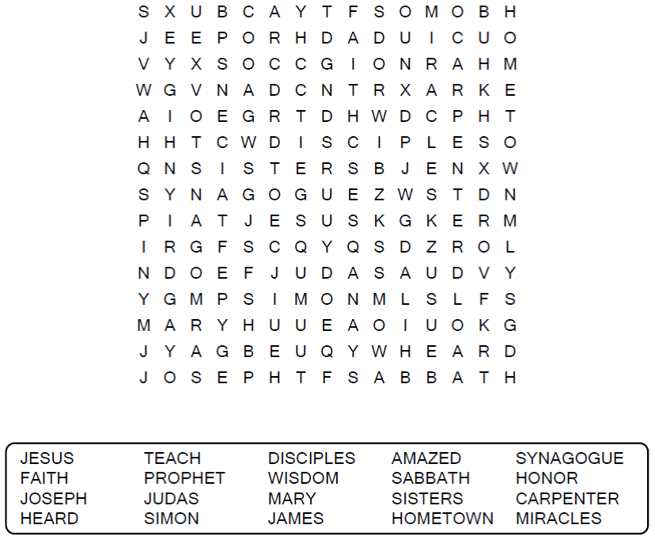

Your Church Name
Any Town, Anywhere

Coloring Page

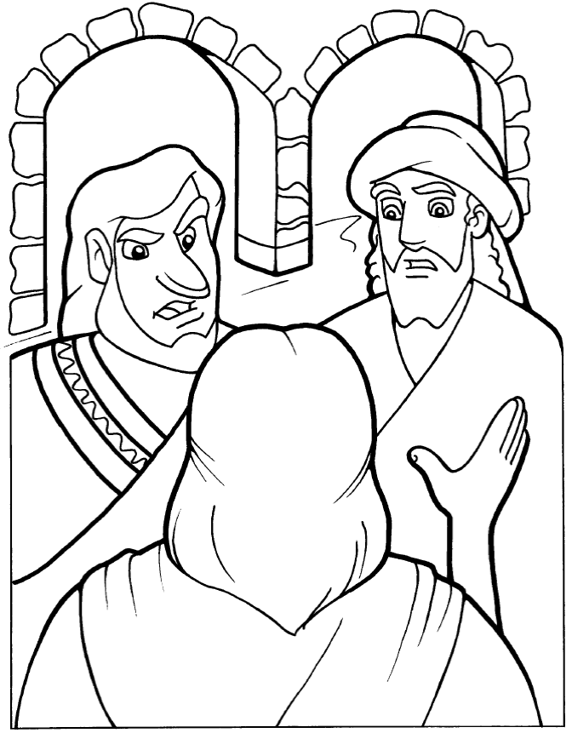
Jesus said to them, "Only in his hometown, among his relatives
and in his own house is a prophet without honor."
Mark 6:4 (NIV)
Copyright © CalvaryCurriculum.com
Used by permission.

Decoder Puzzle

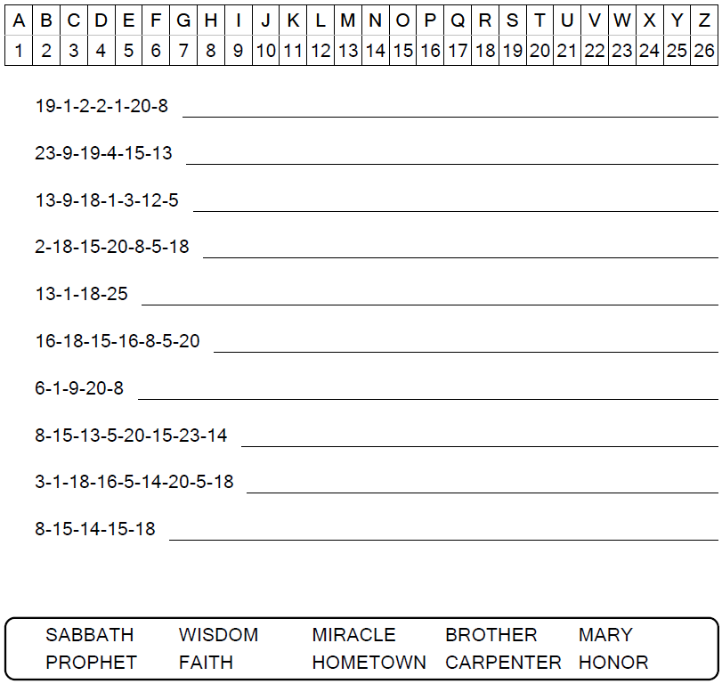

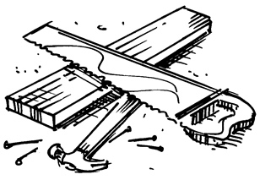
Isn’t this the carpenter?

