Crossword Puzzle

Jesus Raises Jairus' Daughter

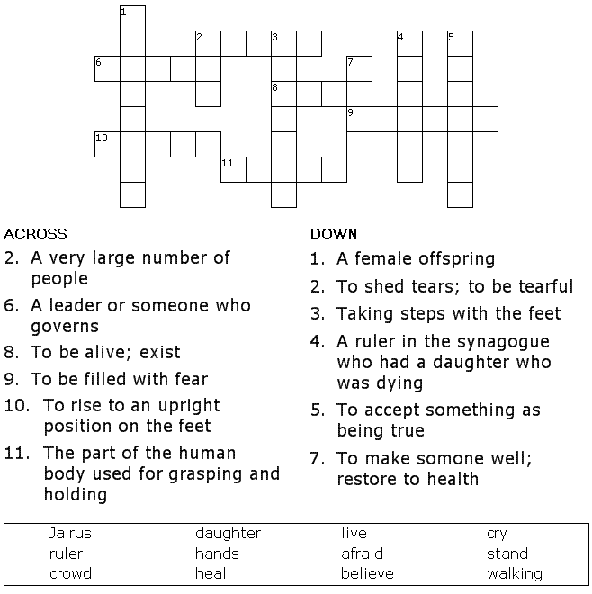

Copyright © Sermons4Kids, Inc.
May be reproduced for Ministry Use

Children’s Worship Bulletin



Mark 5:21- 43

Word Search Puzzle

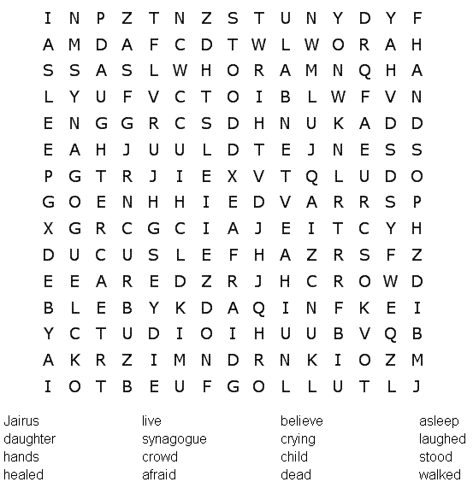

Your Church Name Here
Anytown, USA

Word Jumble

Unscramble each word and then place the numbered letters
in the numbered boxes at the bottom to reveal the answer.

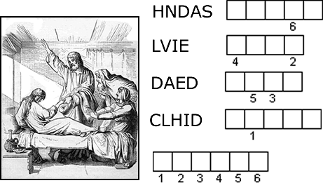

PUZZLE CLUES
1. Jairus asked Jesus to put his _______ on his daughter. Mark 5:23
2. He wanted his daughter to ______. Mark 5:23
3. Some men told Jairus that his daughter was _______. Mark 5:35
4. Jesus said, “The child is not ______, but asleep.” Mark 5:39
Answer: Because of their faith, many people are _________.
Check your answers in Mark 5:21-43 (NIV)

Unscramble each word and then place the numbered letters
in the numbered boxes at the bottom to reveal the answer.

Decoder Puzzle

