Crossword Puzzle

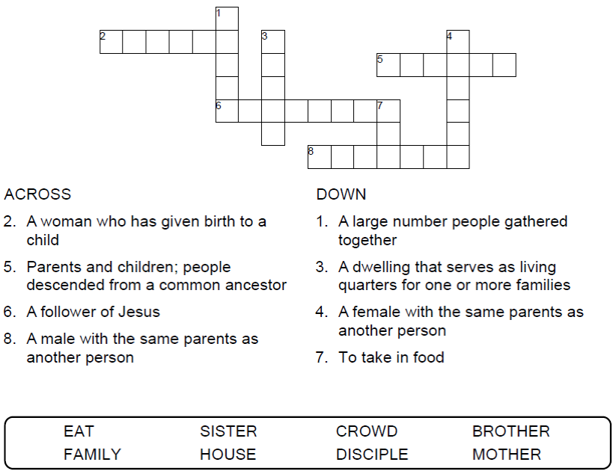
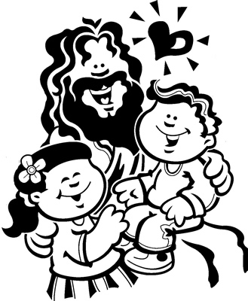

Copyright © Sermons4Kids, Inc.
May be reproduced for Ministry Use
Children’s Worship Bulletin



Mark 3:20-35

Word Search Puzzle

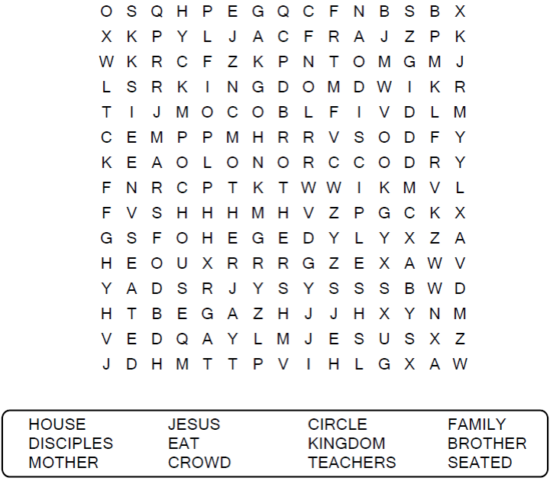
Your Church Name
Your City

Coloring Page

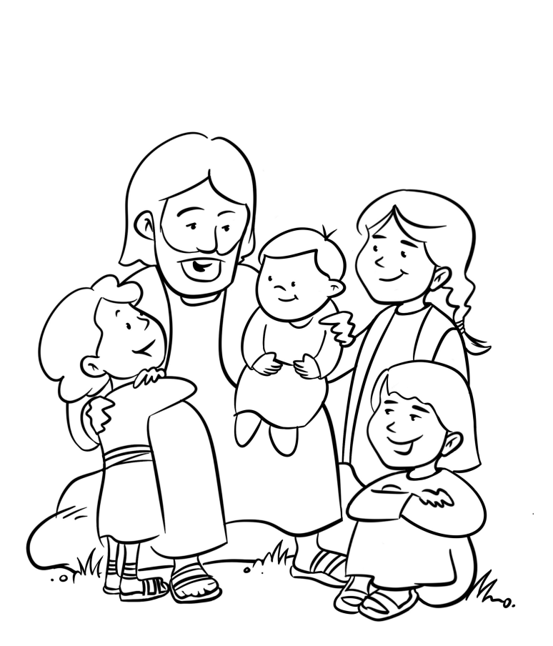

Jesus and the Children

Decoder Puzzle

Each number represents a letter of the alphabet.
Substitute the correct letter for the numbers.

