Crossword Puzzle

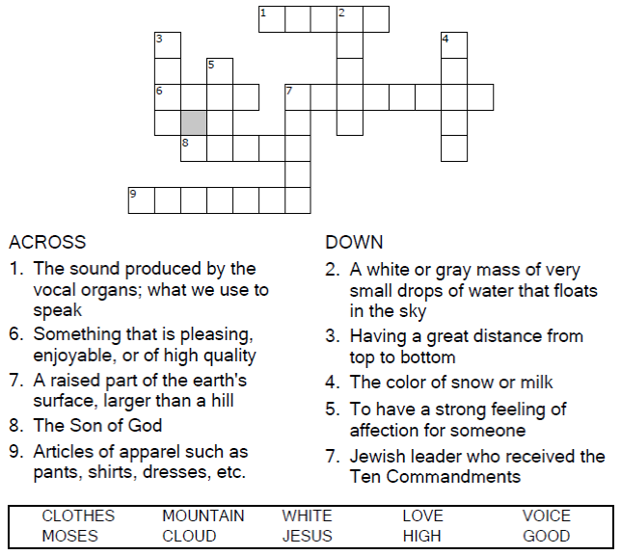
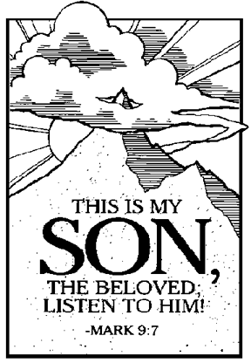
Copyright © Sermons4Kids, Inc.
May be reproduced for Ministry Use
Children’s Worship Bulletin



Mark 9:2-9

Word Search

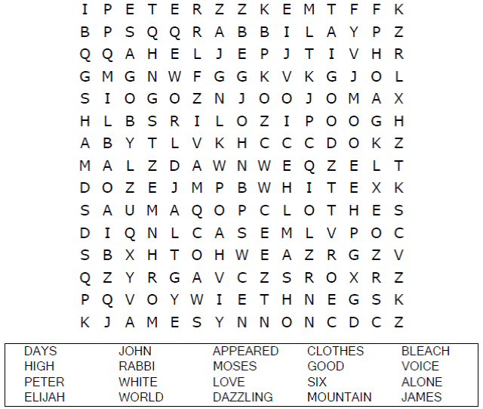
Your Church Name Here
Anytown, Anywhere

Coloring Page

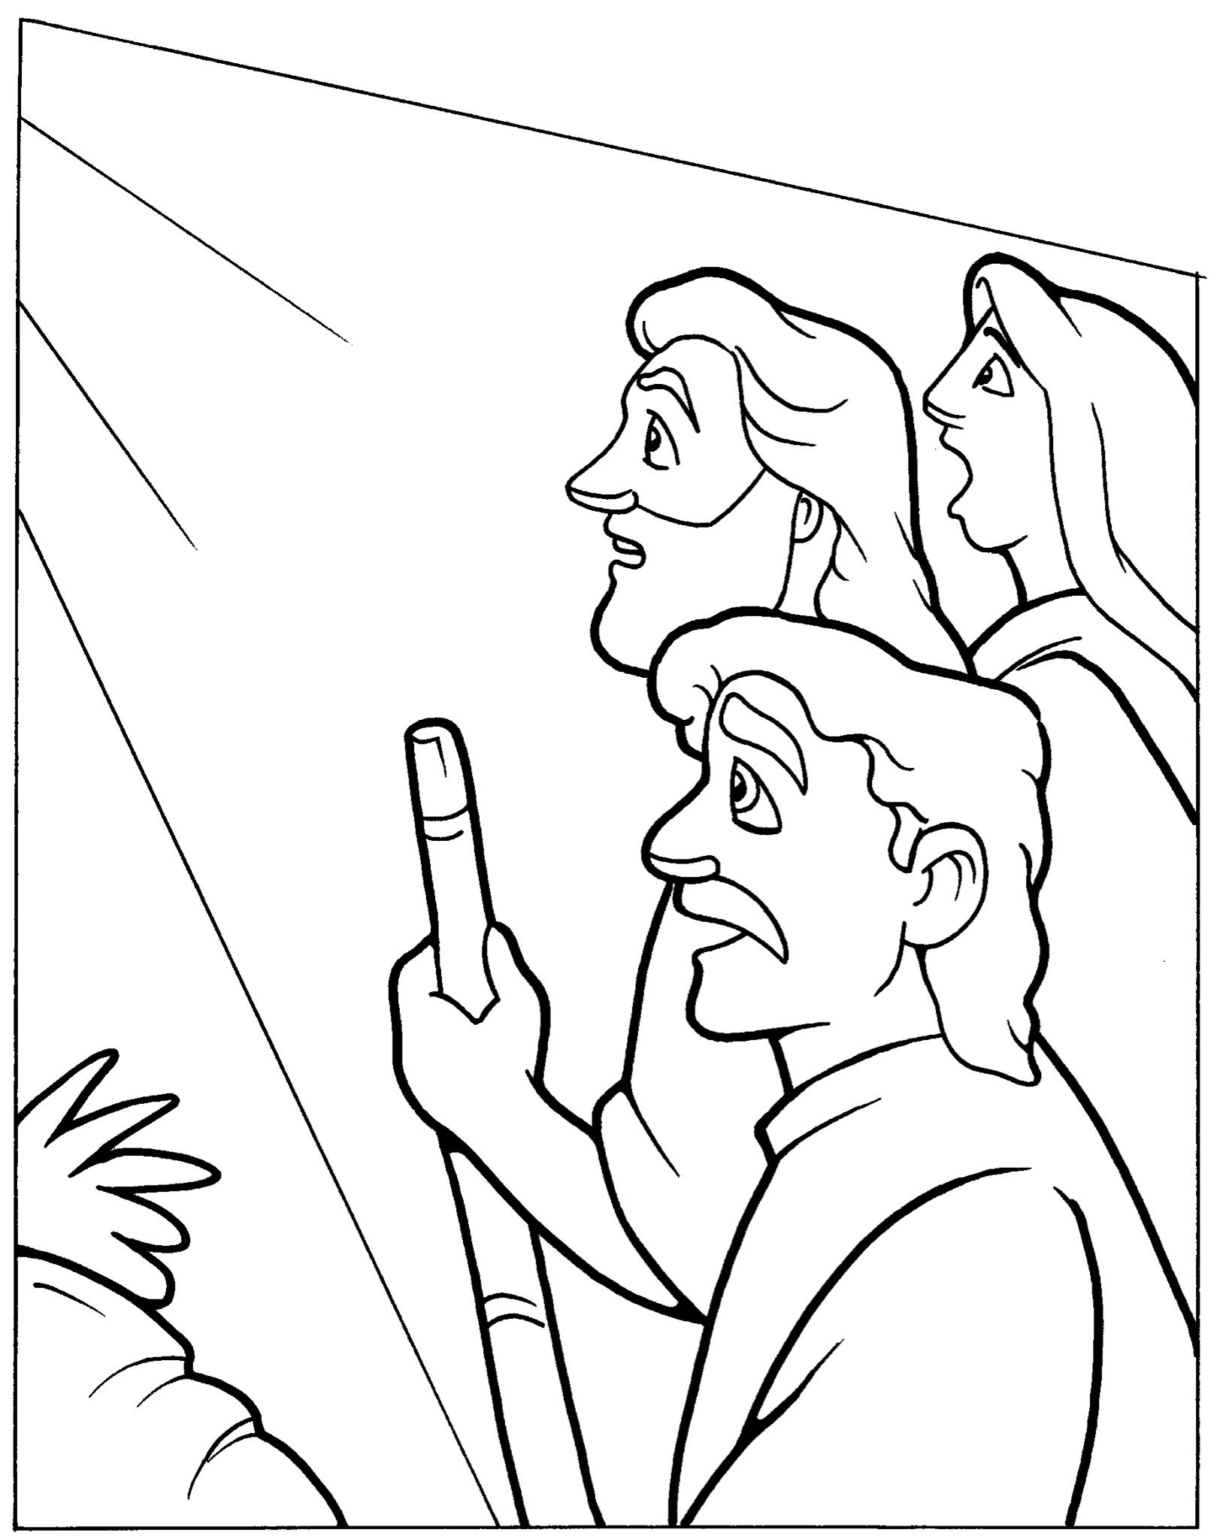
The Transfiguration
Mark 9:2-9

Copyright © CalvaryCurriculum.com
Used with permission

Decoder Puzzle
