Crossword Puzzle

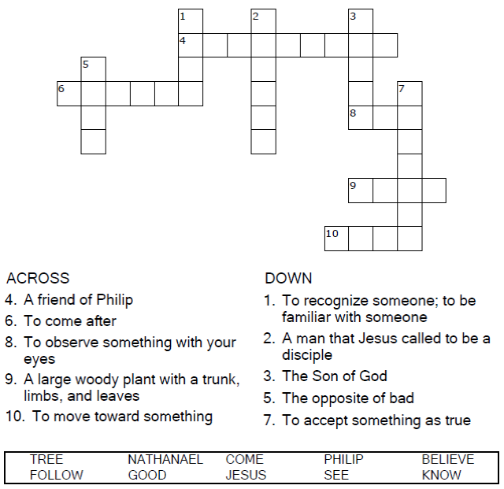

Copyright © Sermons4Kids, Inc.
May be reproduced for Ministry Use
Children’s Worship Bulletin



John 1:43-51

Word Search

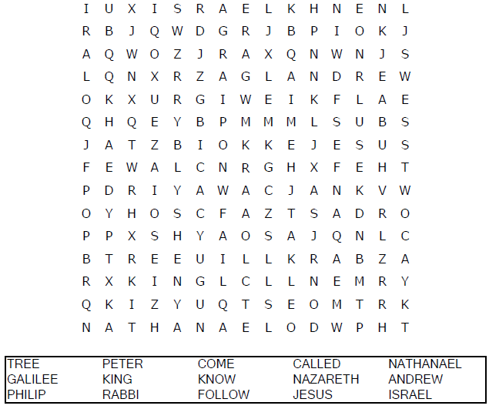
Church Name
Address
City

Decoder Puzzle
Each number represents a letter of the alphabet. Substitute
the correct letter for the numbers to reveal the coded words.

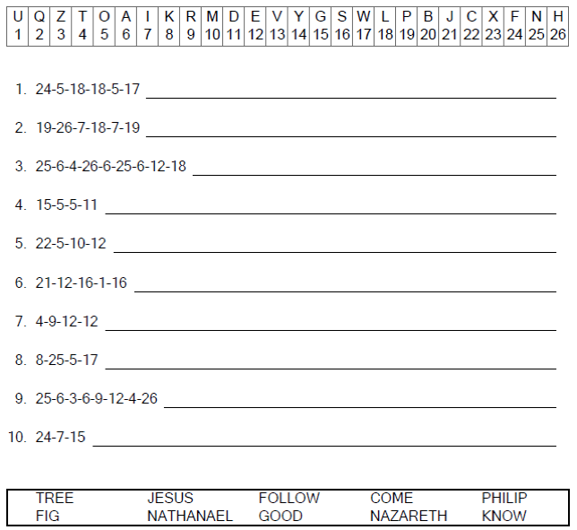

Color Me!

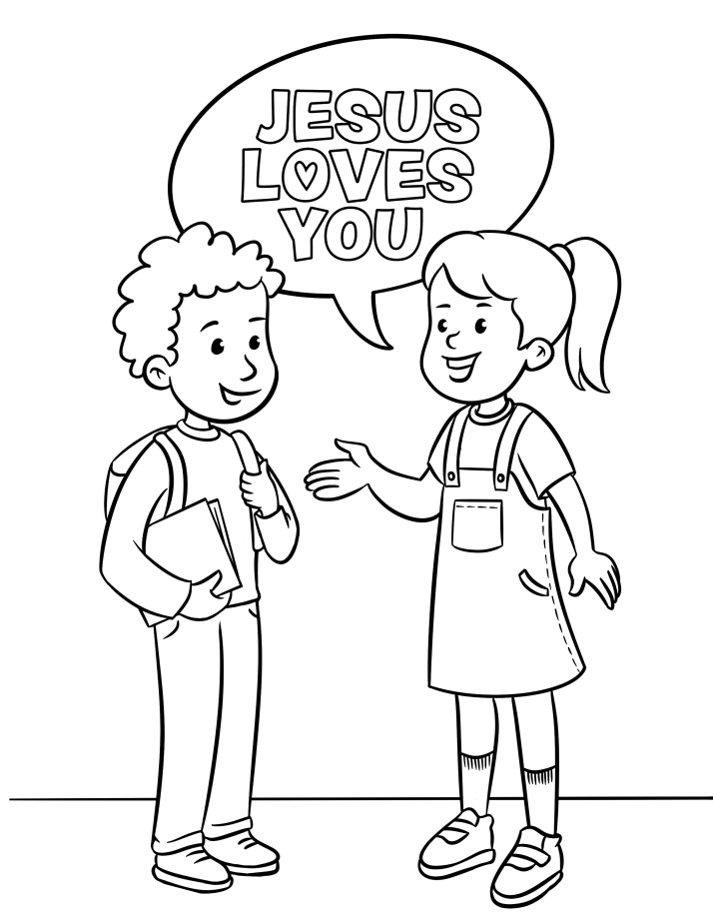
I can tell my friends about Jesus

