Crossword Puzzle

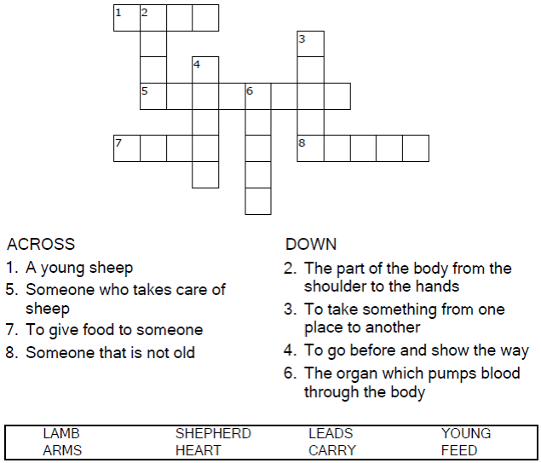

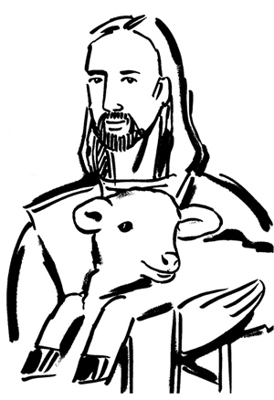
Copyright © Sermons4Kids, Inc.
May be reproduced for Ministry Use

Children’s Worship Bulletin



Isaiah 40:1-11

Word Search Puzzle

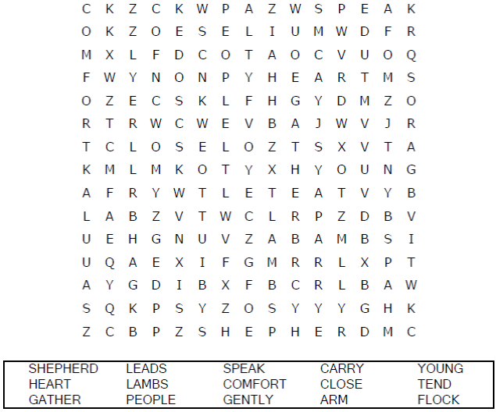
Church Name Here
Church Address
City

Coloring Page

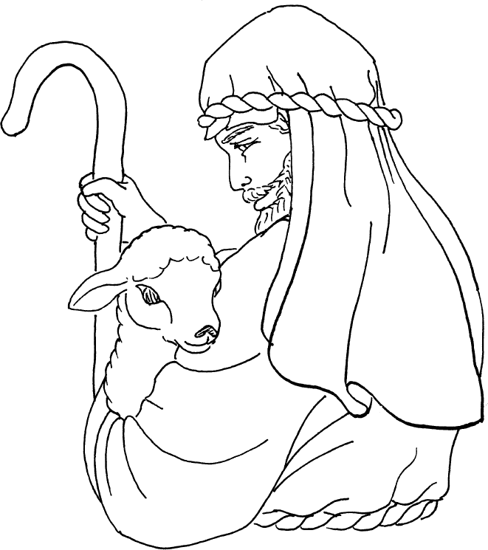
He gathers the lambs in his arms and
carries them close to his heart.
Isaiah 40:11

Copyright © Calvary Curriculum
Used by Permission

Decoder Puzzle

Each number represents a letter of the alphabet.
Substitute the correct letter for the numbers
to reveal the coded words.

