Crossword Puzzle

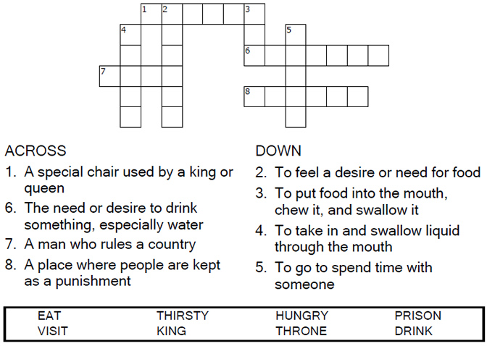

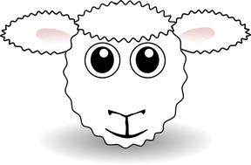
Copyright © Sermons4Kids, Inc.
May be reproduced for Ministry Use

Children’s Worship Bulletin



Matthew 25:31-46

Word Search Puzzle

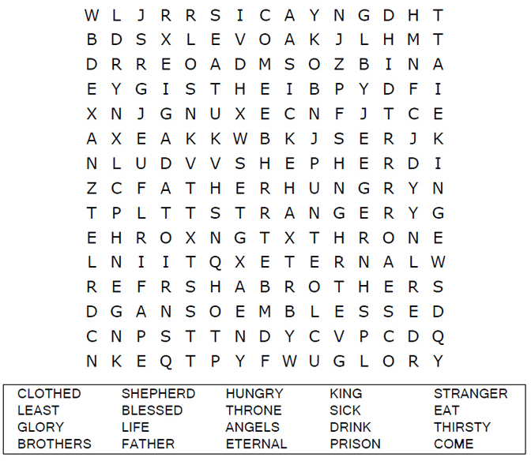
Church Name Here
Church Address
City

Coloring Page

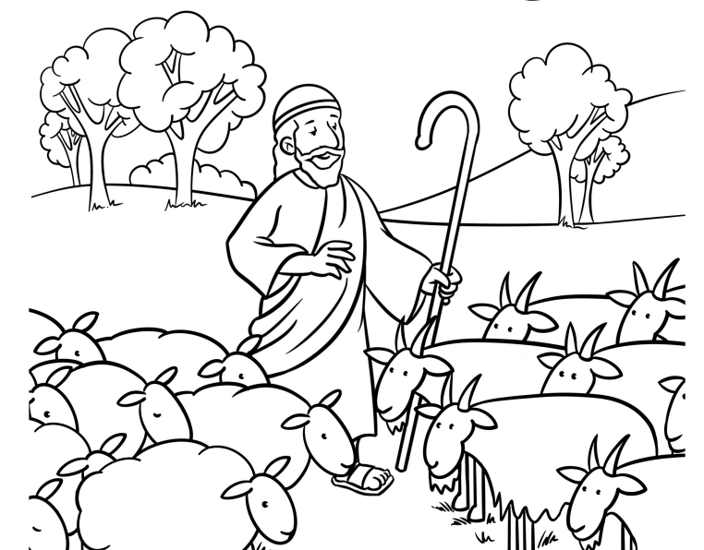
He will put the sheep on his right and the goats on his left."
Matthew 25:33 (NIV)

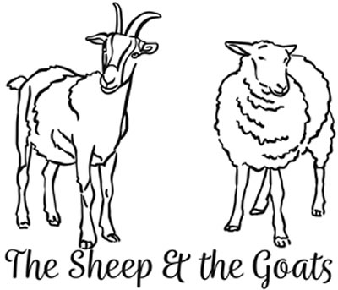

Multiple Choice

Choose the answer that best matches the definition.



