Crossword Puzzle

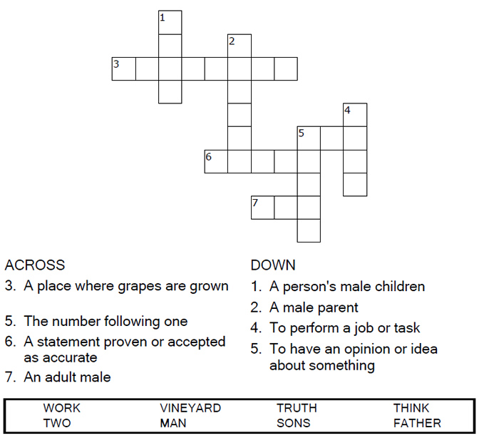


Copyright © Sermons4Kids, Inc.
May be reproduced for Ministry Use
Children’s Worship Bulletin



Matthew 21:28-32

Word Search Puzzle

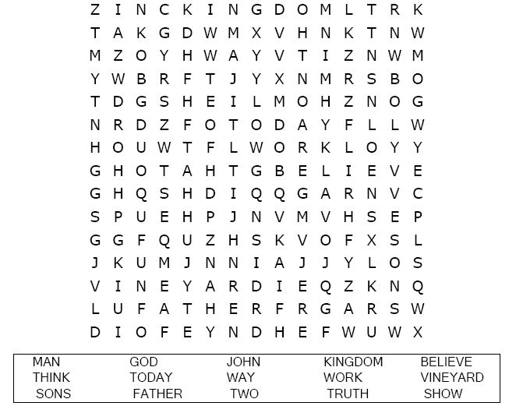

Your Church Name
Address
City

Coloring Page
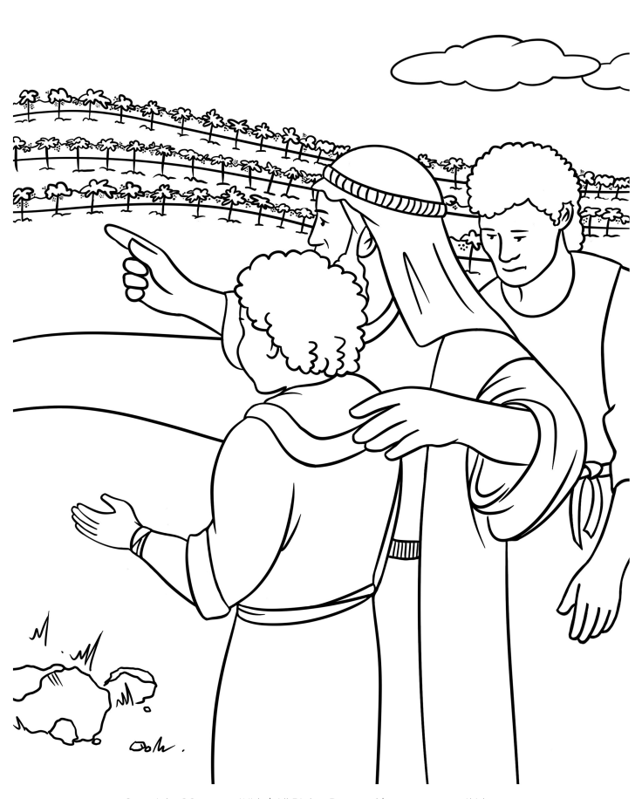
The Parable of the Two Sons
Matthew 21:28-30

Decoder Puzzle

Each number represents a letter of the alphabet. Substitute
the correct letter for the numbers to reveal the coded words.

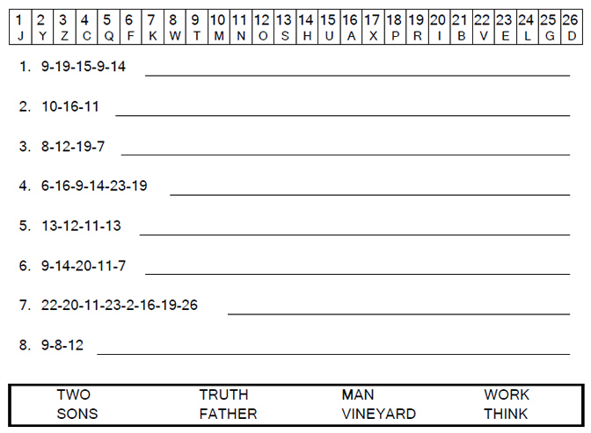

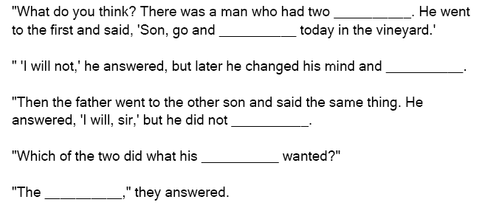

Fill in the Blanks

You can find the answers in Matthew 21:28-30 (NIV)

