Spiral Puzzle

Look at the numbered clues. Choose the correct word and write
it in the puzzle. Each numbered square starts a new word.
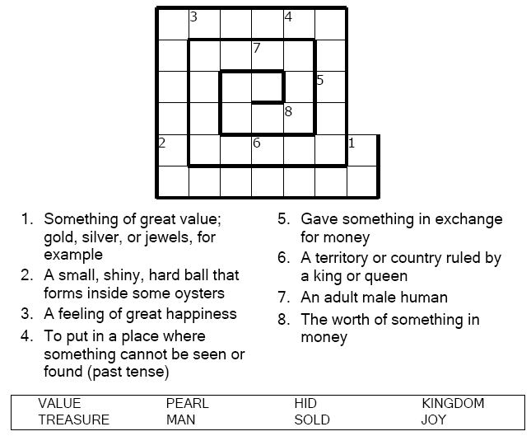
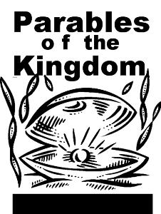

Copyright © Sermons4Kids, Inc.
May be reproduced for Ministry Use
Children’s Worship Bulletin



Matthew 13:44-52

Word Search Puzzle

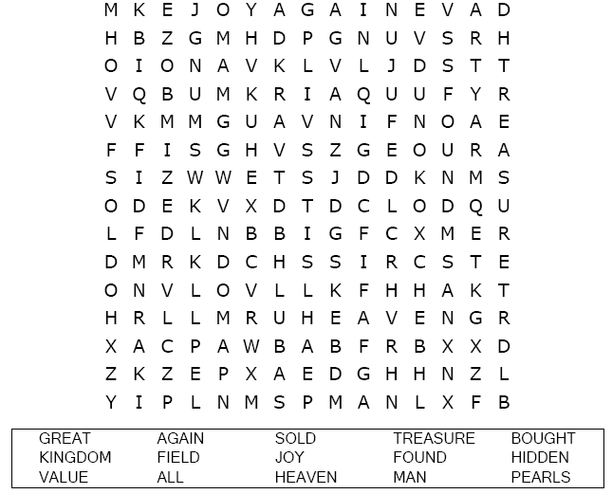
Your Church Name Here
Church Address
City

Coloring Page
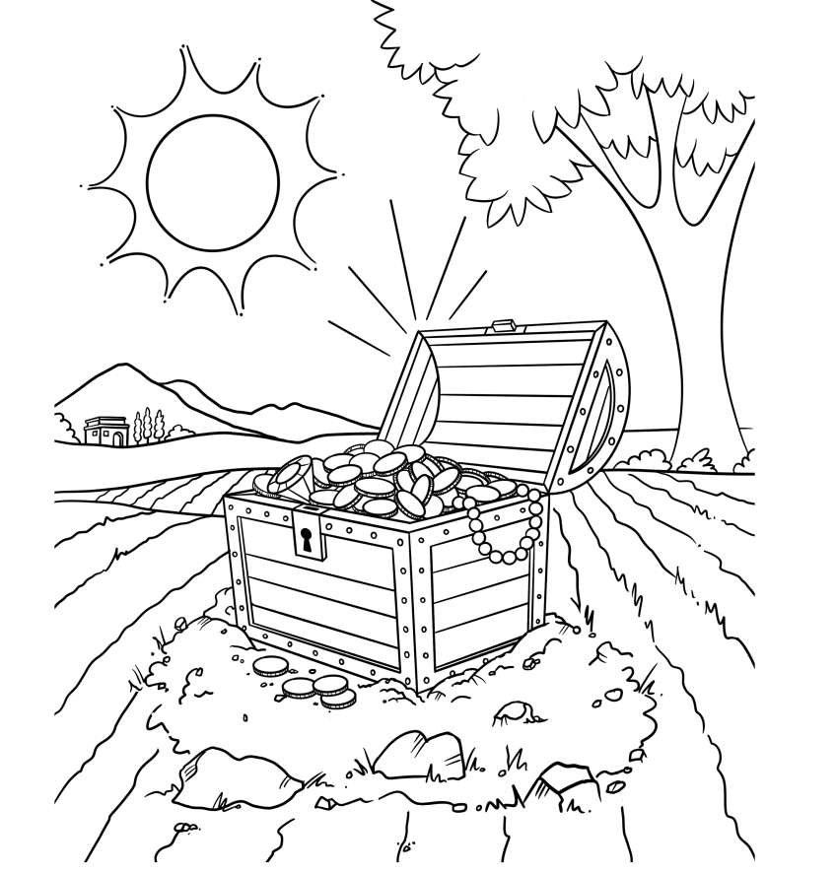
The Treasure in the Field
The kingdom of heaven is like a treasure hidden in a field, which someone found and hid; then in his joy he goes and sells all that he has and buys that field.
Matthew 13:44

Multiple Choice Quiz

Choose the word that best fits the definition.

