Crossword Puzzle

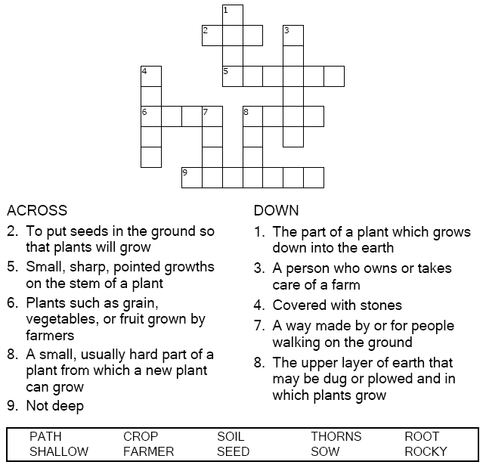


Copyright © Sermons4Kids, Inc.
May be reproduced for Ministry Use
Children’s Worship Bulletin



Mathew 13:18-23

Word Search Puzzle

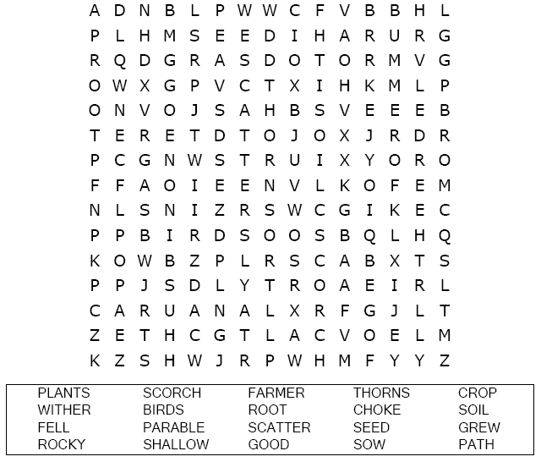

Coloring Page
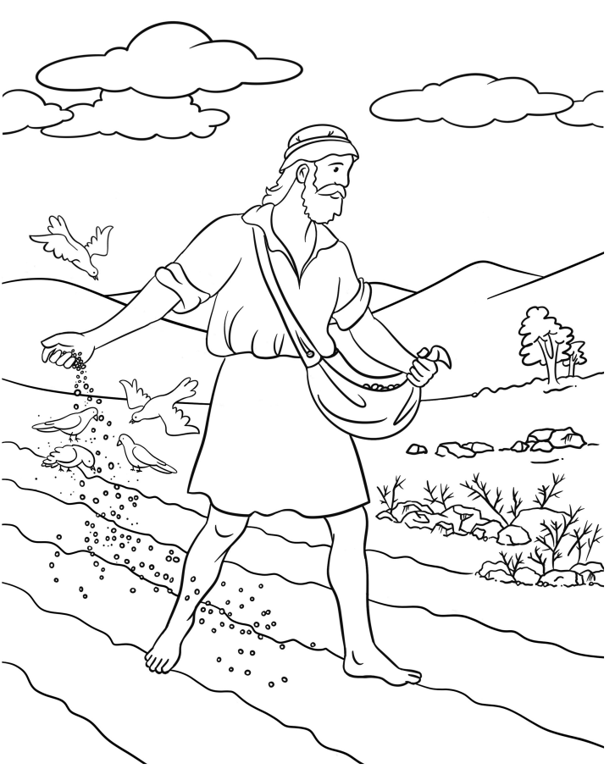
The Parable of the Sower

Multiple Choice Quiz

Choose the word that best matches the definition.

