Crossword Puzzle

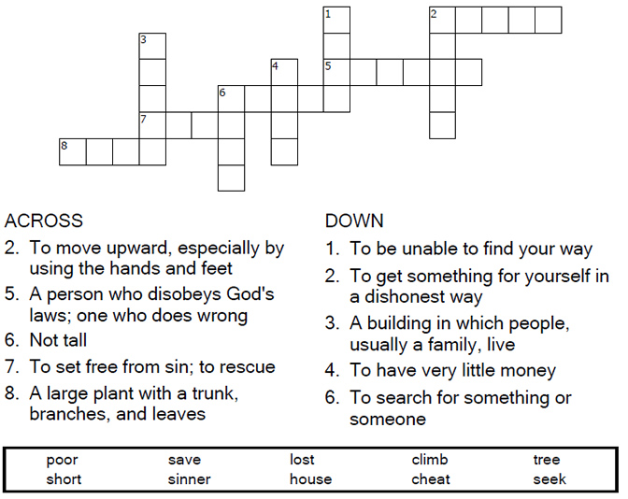
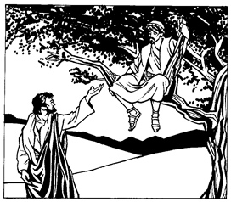

Copyright © Sermons4Kids, Inc.
May be reproduced for Ministry Use
Children’s Worship Bulletin



Luke 19:1-10

Word Search Puzzle

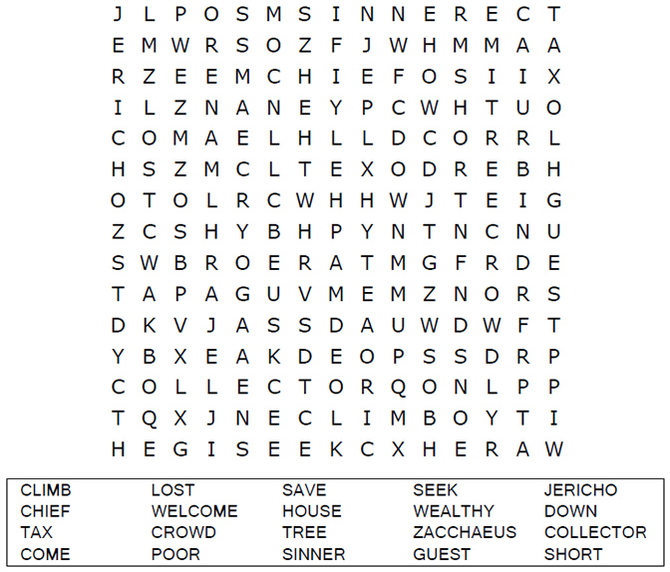
Your Church Name
Address
City

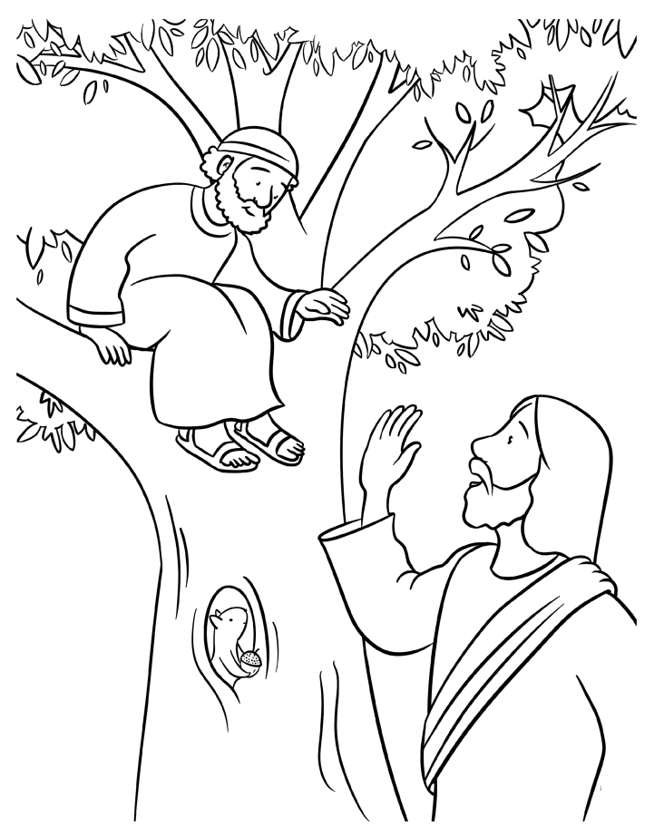
Jesus and Zacchaeus
Luke 19

Decoder Puzzle

Each number represents a letter of the alphabet. Substitute
the correct letter for the numbers to reveal the coded words.

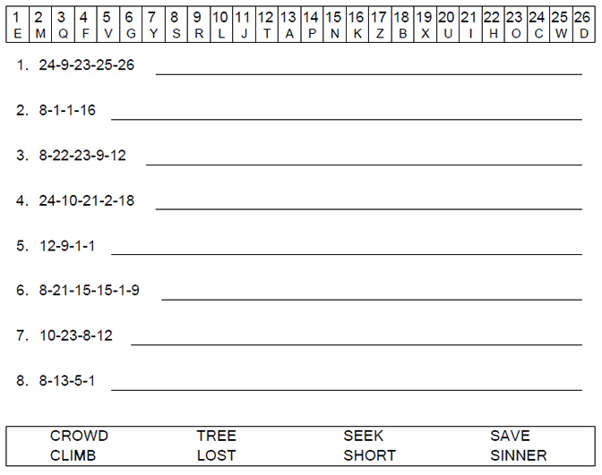
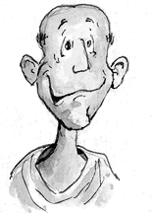
Zacchaeus © Henry Martin

