Crossword Puzzle

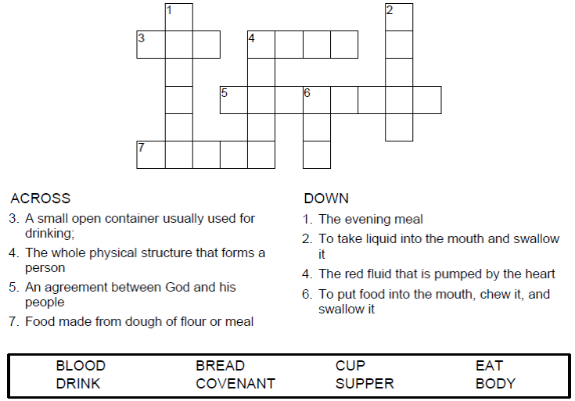
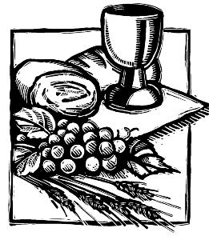

Copyright © Sermons4Kids, Inc.
May be reproduced for Ministry Use
Children’s Worship Bulletin



1 Corinthians 11:26-29

Word Search Puzzle

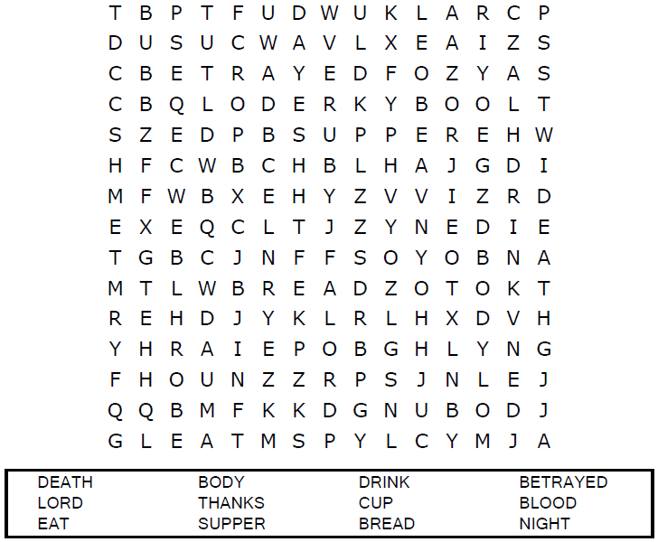
Your Church Name
Any Town, Anywhere

Coloring Page

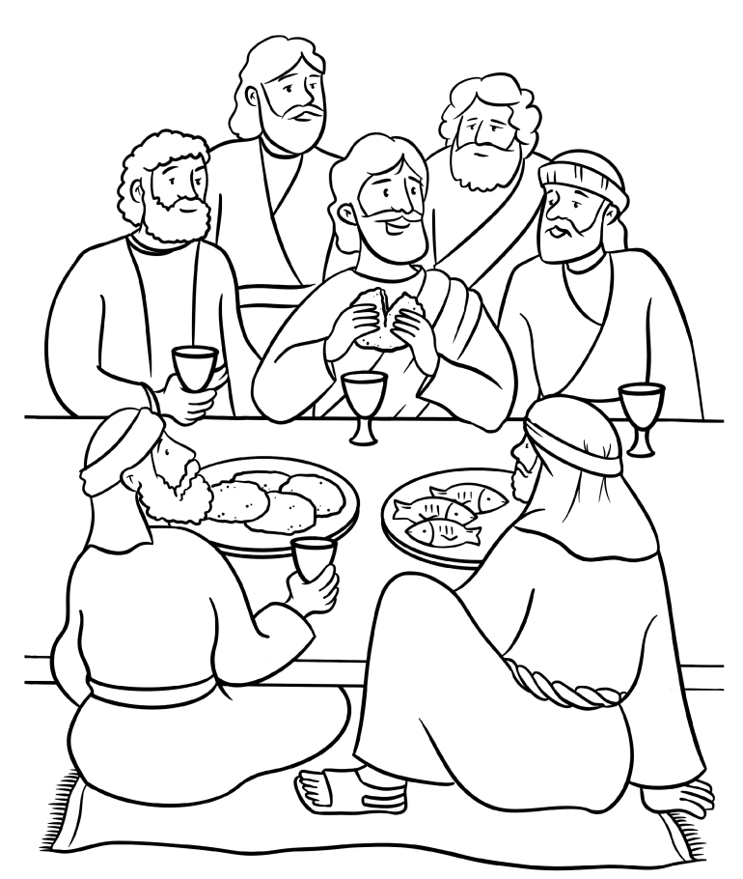

IN REMEMBRANCE OF ME

From Thru-the-Bible Coloring Pages for Ages 4-8. © Standard Publishing.
Used by permission. Reproducible Coloring Books may be purchased
from Standard Publishing, www.standardpub.com, 1-800-543-1301.

Decoder Puzzle

Each number represents a letter of the alphabet. Substitute the
correct letter for the numbers to reveal the coded words.

