Crossword Puzzle

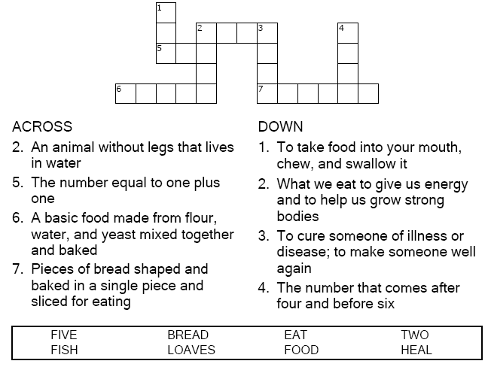

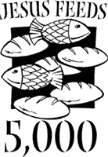

Copyright © Sermons4Kids, Inc.
May be reproduced for Ministry Use

Children’s Worship Bulletin



Matthew 14:13-21

Word Search Puzzle

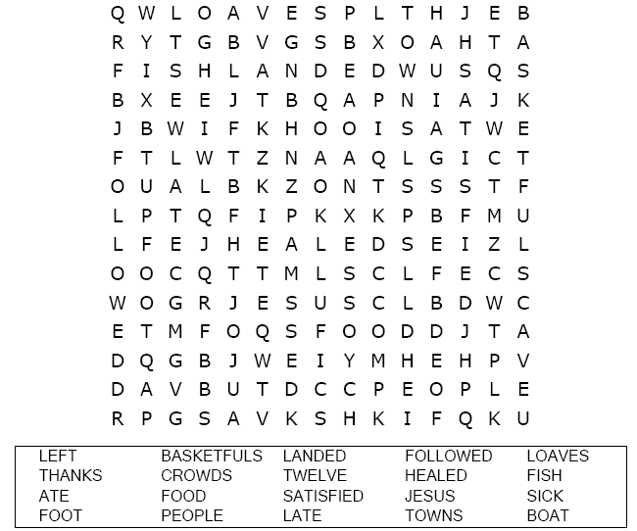
Your Church’s Name
Address
City, State

Coloring Page
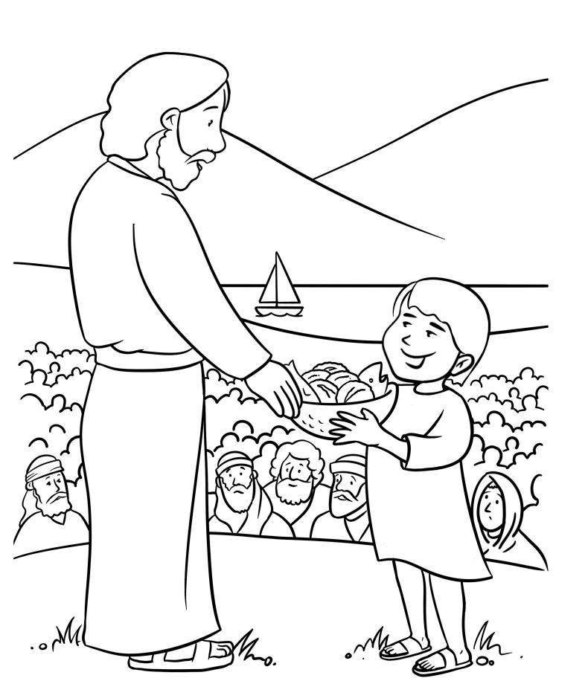
Jesus can feed a crowd with a little food.

Multiple Choice Quiz

Choose the word that best fits the definition.

