Crossword Puzzle

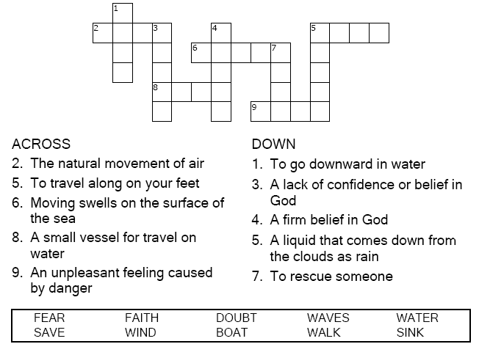
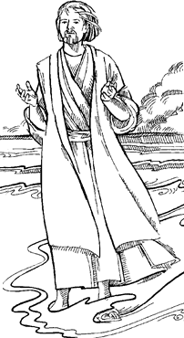

Copyright © Sermons4Kids, Inc.
May be reproduced for Ministry Use
Children’s Worship Bulletin



Matthew 14:22-33

Word Search Puzzle

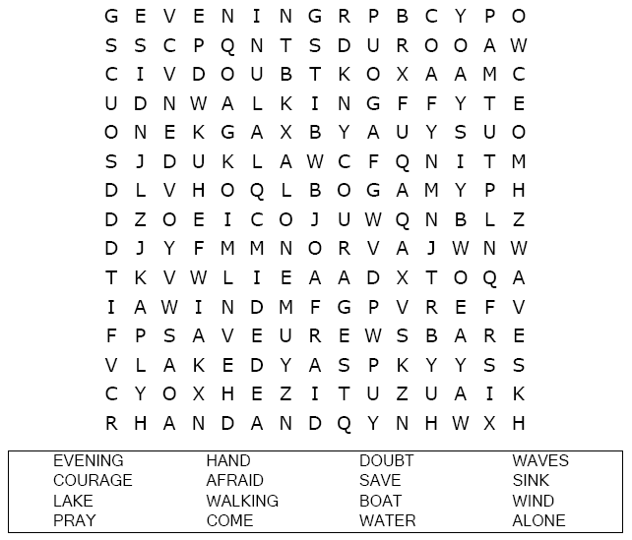
Your Church’s Name
Address
City, State

Coloring Page
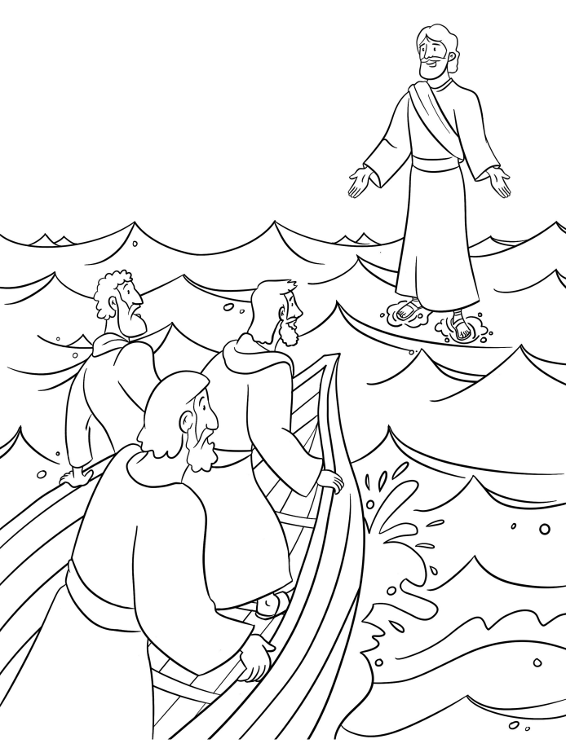
Jesus Walks on Water

Decoder Puzzle

Each number represents a letter of the alphabet. Substitute
the correct letter for the numbers to reveal the coded words.
