Crossword Puzzle

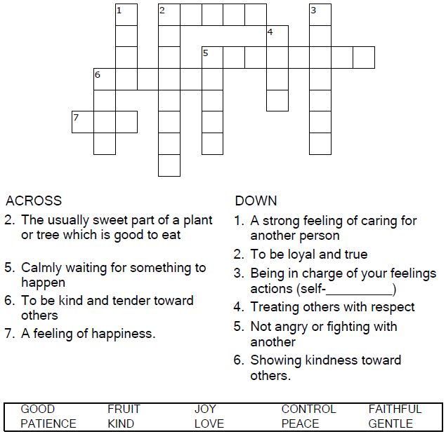


Copyright © Sermons4Kids, Inc.
May be reproduced for Ministry Use
Children’s Worship Bulletin



Galatians 5:22-23

Word Search Puzzle

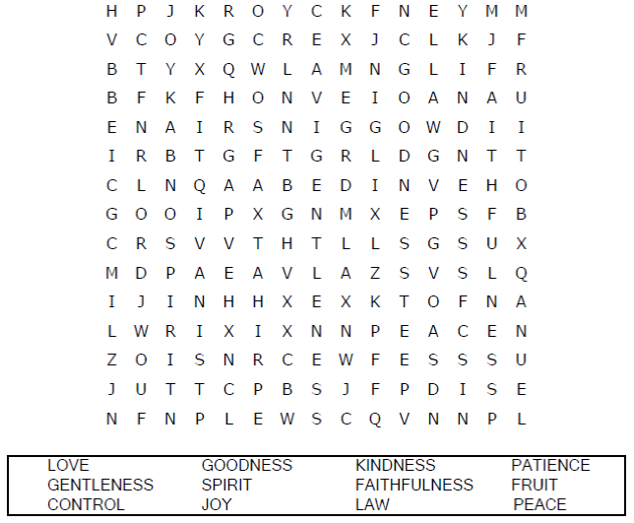

Your Church Name
Any Town, Anywhere

Coloring Page

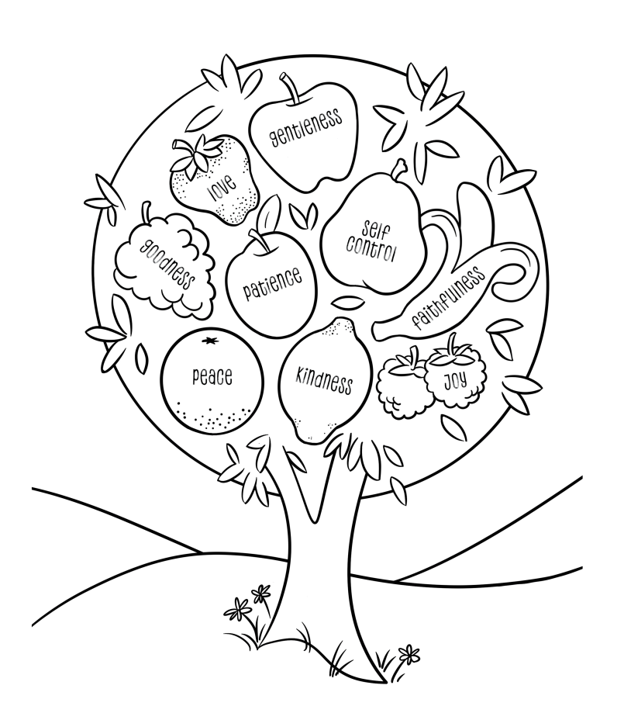
But the fruit of the Spirit is love, joy, peace, patience, kindness, goodness, faithfulness,
gentleness and self-control.
Galatians 5:22-23

Decoder Puzzle

