Crossword Puzzle

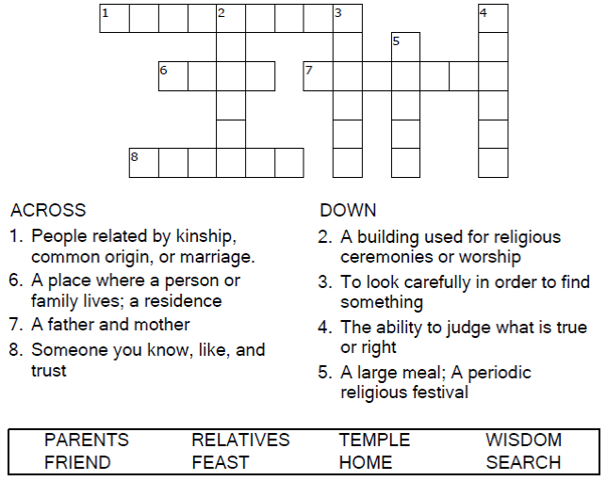

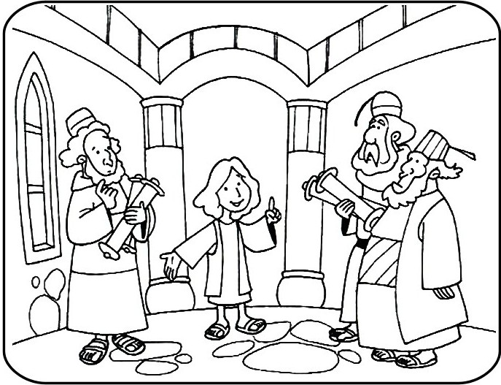
Copyright © Sermons4Kids, Inc.
May be reproduced for Ministry Use
Children’s Worship Bulletin



Luke 2:41-52

Word Search Puzzle

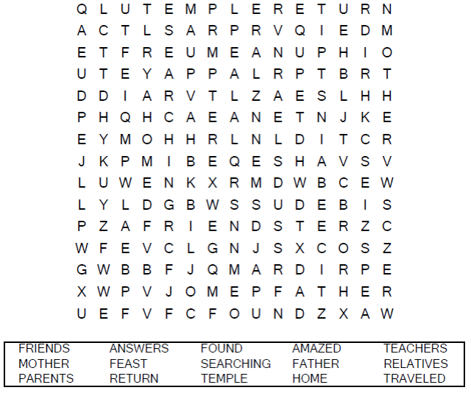
Your Church Name Here
Anytown, Anywhere

Coloring Page

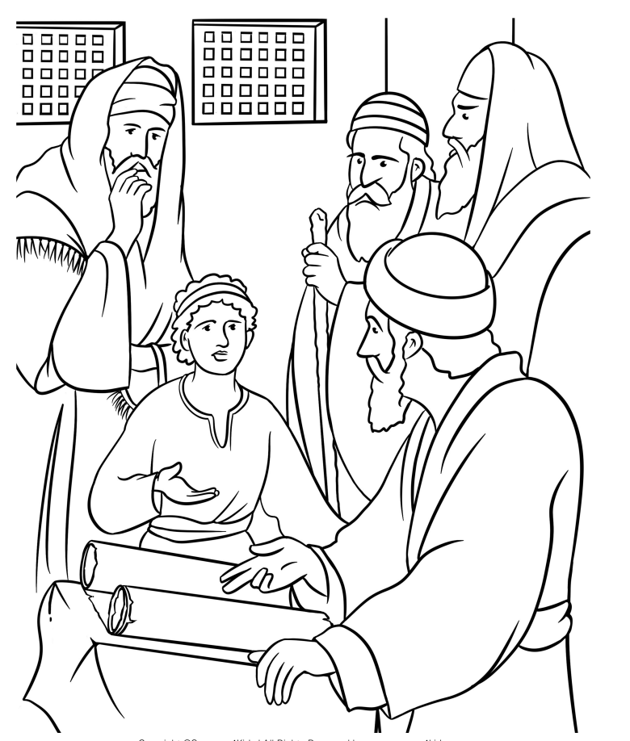
Jesus in the Temple
Luke 2

Maze Puzzle

Can you help Mary and Joseph find Jesus in the Temple?

