Crossword Puzzle

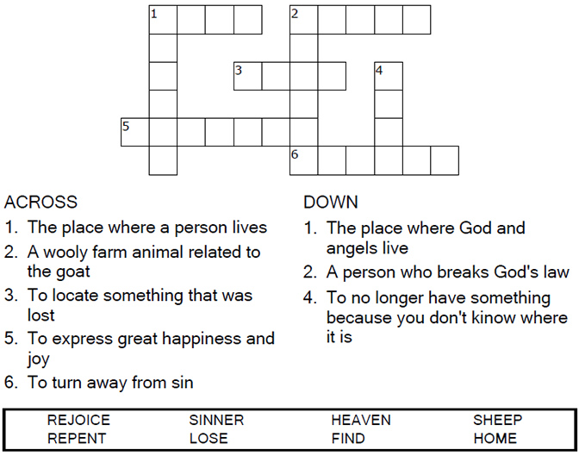
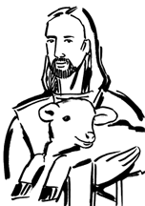

Copyright © Sermons4Kids, Inc.
May be reproduced for Ministry Use
Children’s Worship Bulletin



Luke 15:1-7

Word Search Puzzle

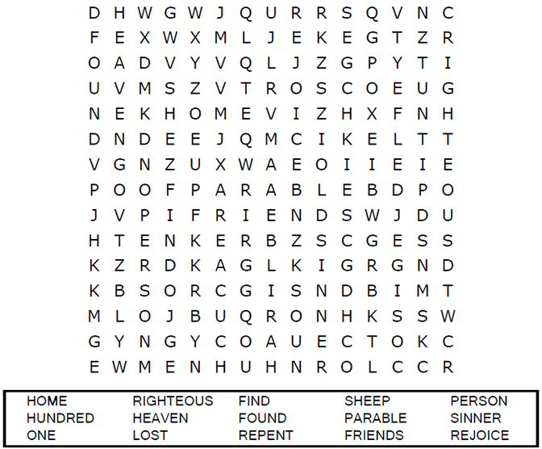
Your Church Name
Your City

Coloring Page

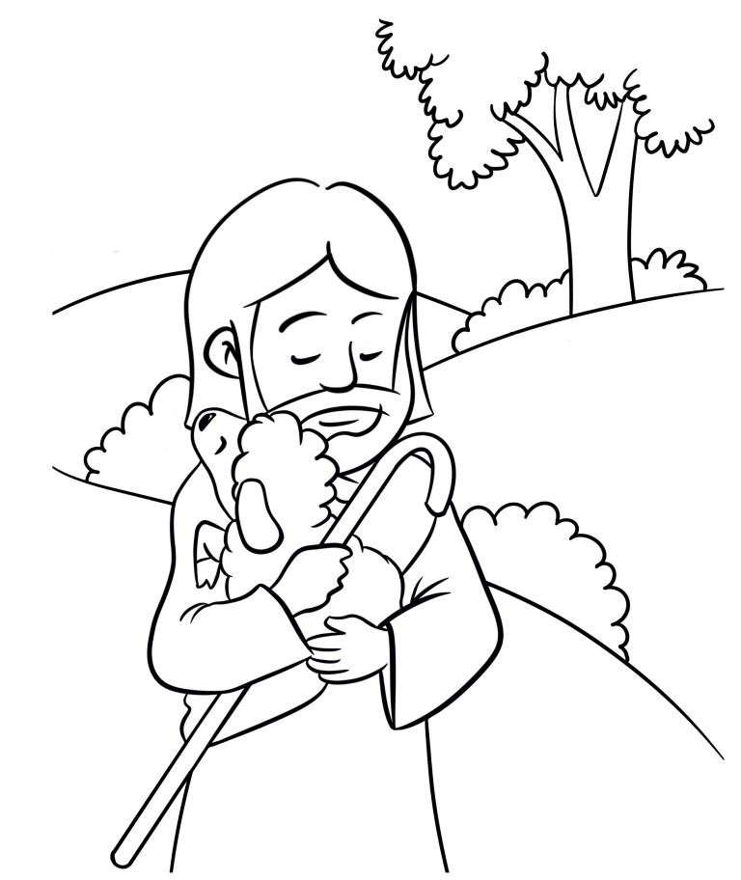

The Parable of the Lost Sheep

Decoder Puzzle

Each number represents a letter of the alphabet. Substitute
the correct letter for the numbers to reveal the coded words.

