Crossword Puzzle

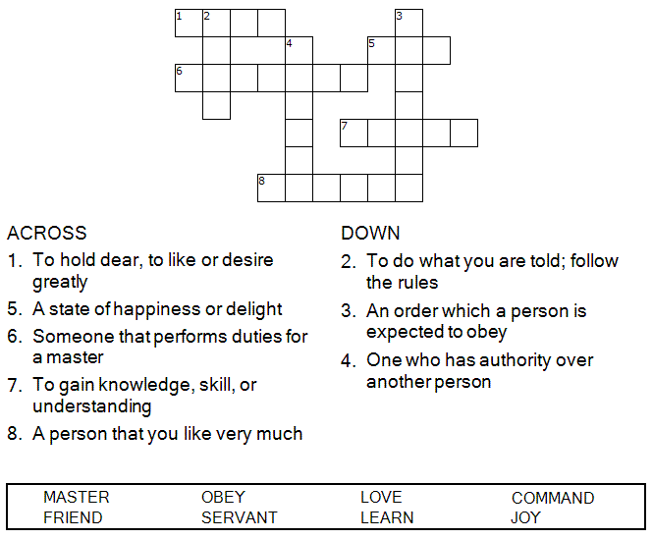



Copyright © Sermons4Kids, Inc.
May be reproduced for Ministry Use
Children’s Worship Bulletin



John 15:9-17

Word Search Puzzle

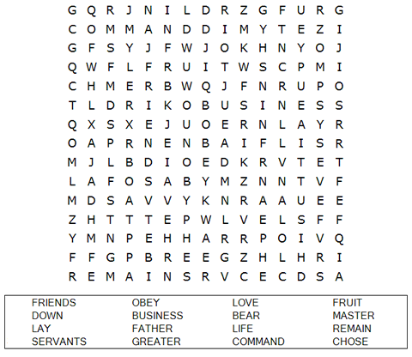

Your Church Name Here
Anytown, USA

Coloring Page

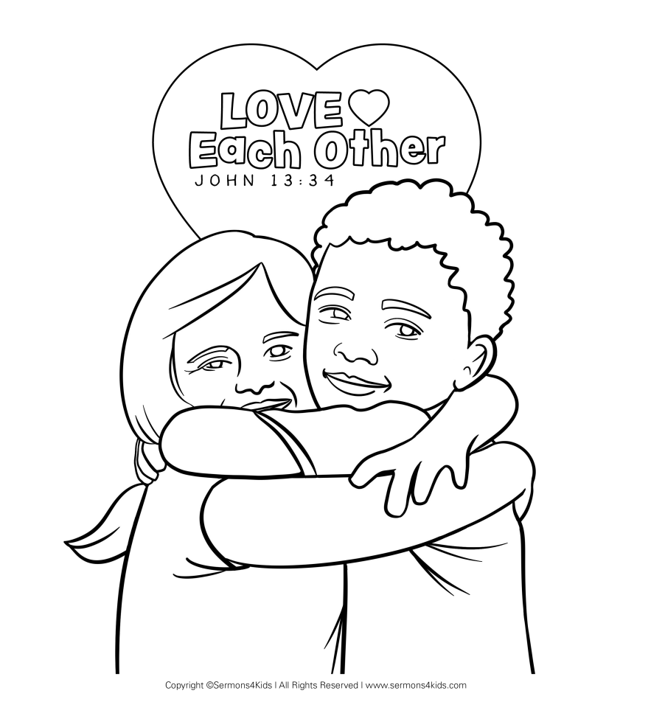

"My command is this: Love each other as I have loved you. Greater love has no one than this, that he lay down his life for his friends. You are my friends if you do what I command."

John 15:12-14 (NIV)

Decoder Puzzle
Each number represents a letter of the alphabet. Substitute
the correct letter for the numbers to reveal the coded words.

