Crossword Puzzle

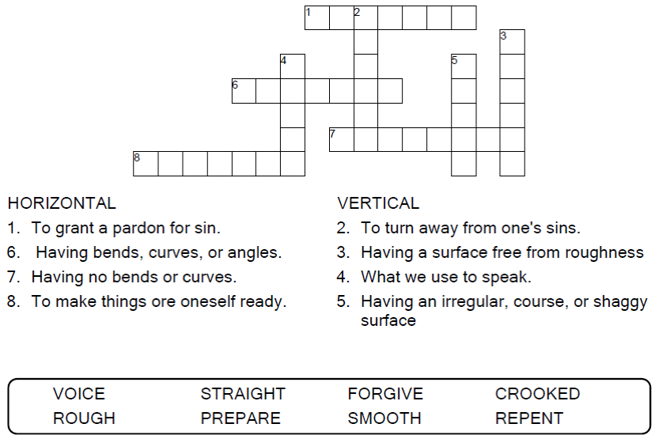

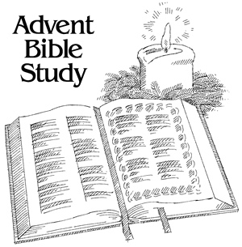

Copyright © Sermons4Kids, Inc.
May be reproduced for Ministry Use

Children’s Worship Bulletin



Luke 3:1-6

Word Search Puzzle

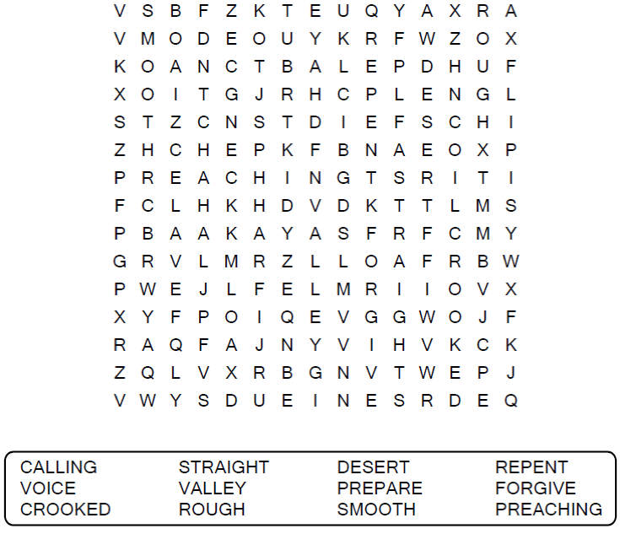

Your Church Name Here
Anytown, USA

Coloring Page

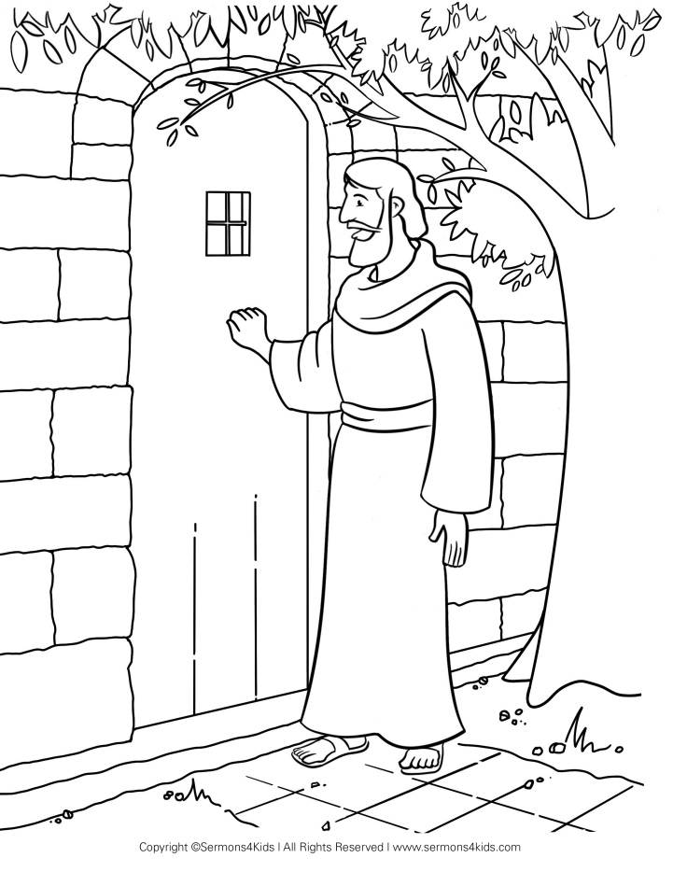

Decoder Puzzle
Each number represents a letter of the alphabet. Substitute the
correct letter for the numbers to reveal the coded words.

