Crossword Puzzle

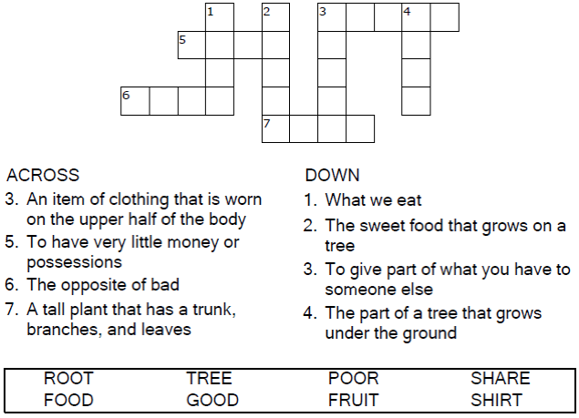

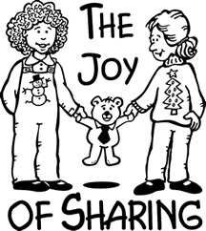

Copyright © Sermons4Kids, Inc.
May be reproduced for Ministry Use
Children’s Worship Bulletin



Luke 3:7-11

Word Search Puzzle

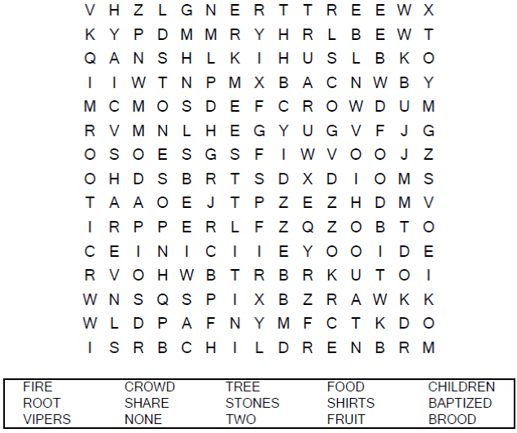

Your Church Name Here
Anytown, Anywhere

Coloring Page

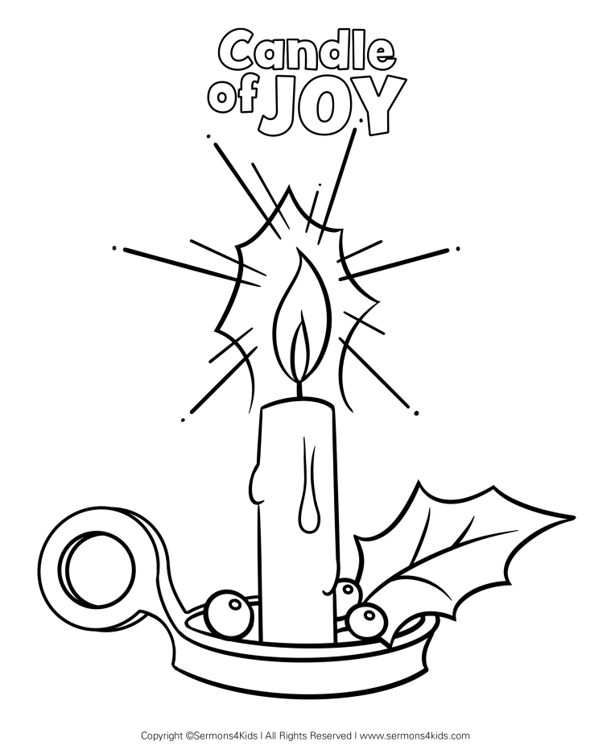

The Candle of Joy

Decoder Puzzle
Each number represents a letter of the alphabet. Substitute the
correct letter for the numbers to reveal the coded words.

