Crossword Puzzle

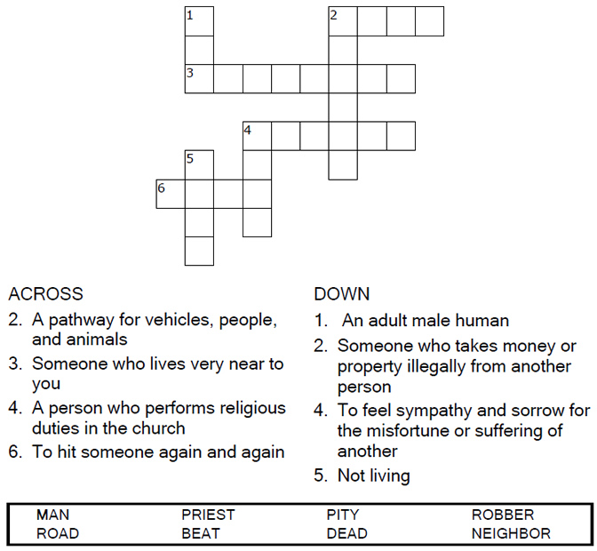

Copyright © Sermons4Kids, Inc.
May be reproduced for Ministry Use

Children’s Worship Bulletin



Luke 10:25-37

Word Search

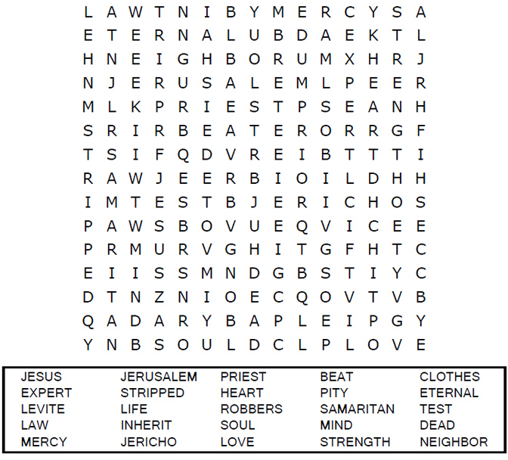

Decoder Puzzle
Each number represents a letter of the alphabet. Substitute
the correct letter for the numbers to reveal the coded words.

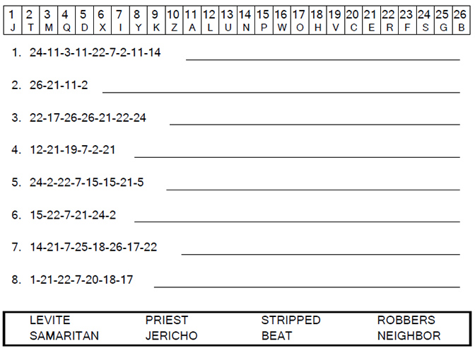
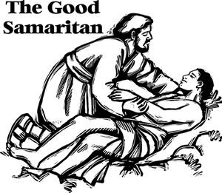

Coloring Page

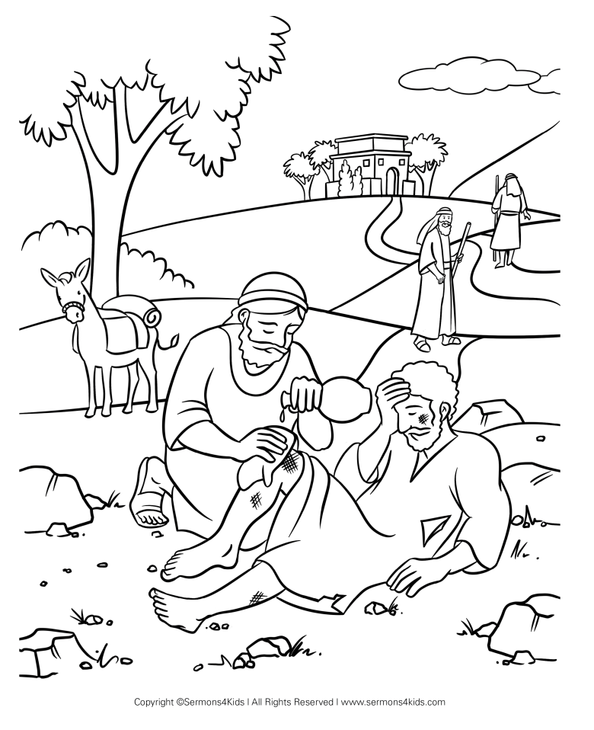

"Which of these three do you think was a neighbor
to the man who fell into the hands of robbers?"
Luke 10:36

