Crossword Puzzle

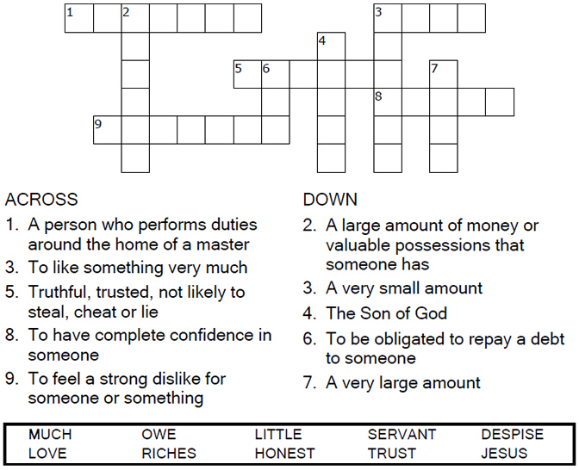
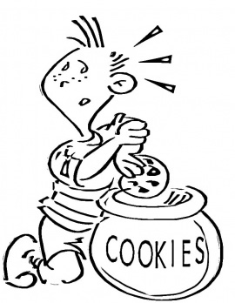

Copyright © Sermons4Kids, Inc.
May be reproduced for Ministry Use
Children’s Worship Bulletin



Luke 16:1-13

Word Search Puzzle

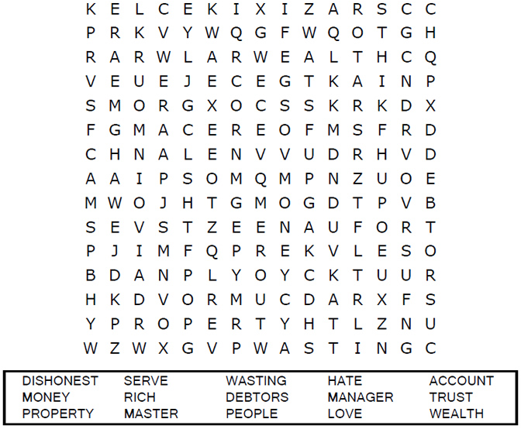
Your Church’s Name
Address
City, State

Coloring Page
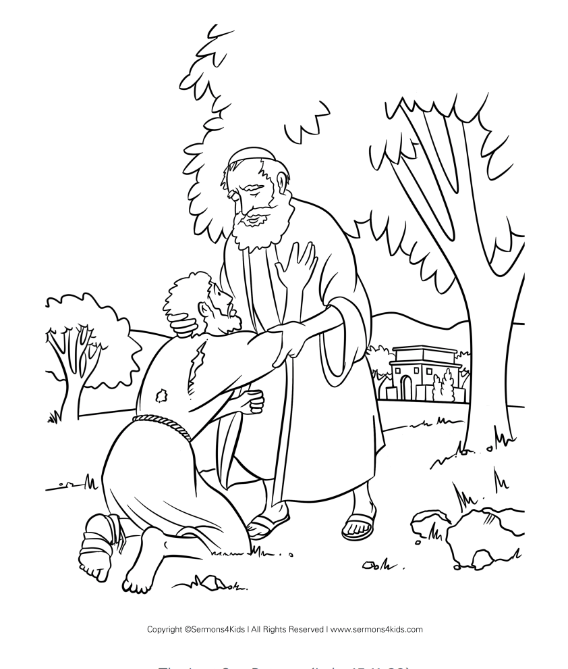
I will follow Jesus when I am tempted to do wrong.

Multiple Choice Quiz

Each number represents a letter of the alphabet. Substitute
the correct letter for the numbers to reveal the coded words.

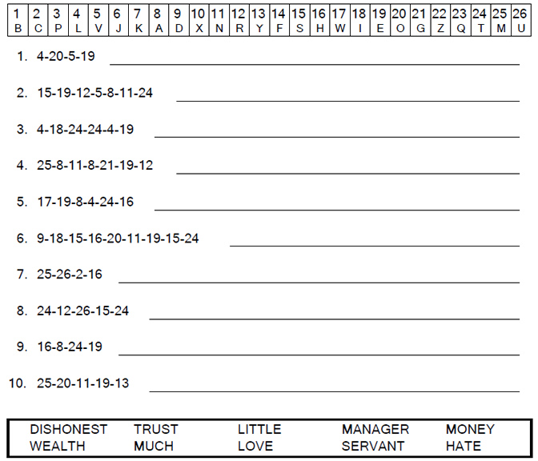

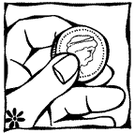
“Whoever can be trusted with very little can also be trusted with much, and whoever is dishonest with very little will
also be dishonest with much.”
Luke 16:10

