Crossword Puzzle

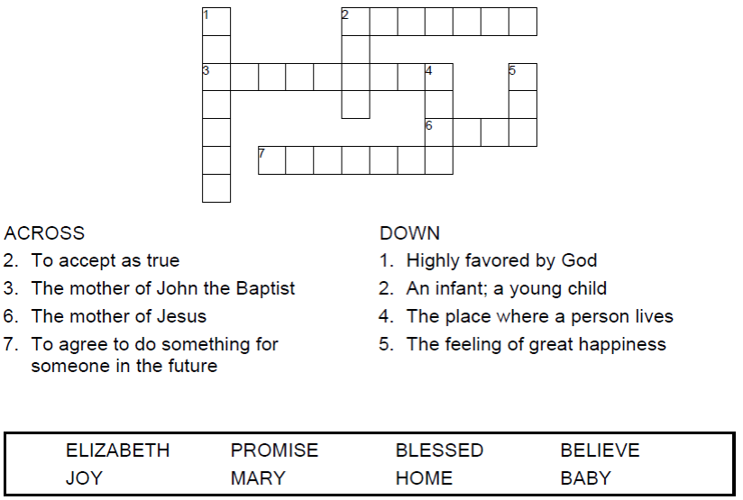


Copyright © Sermons4Kids, Inc.
May be reproduced for Ministry Use

Children’s Worship Bulletin



Luke 1:39-45

Word Search

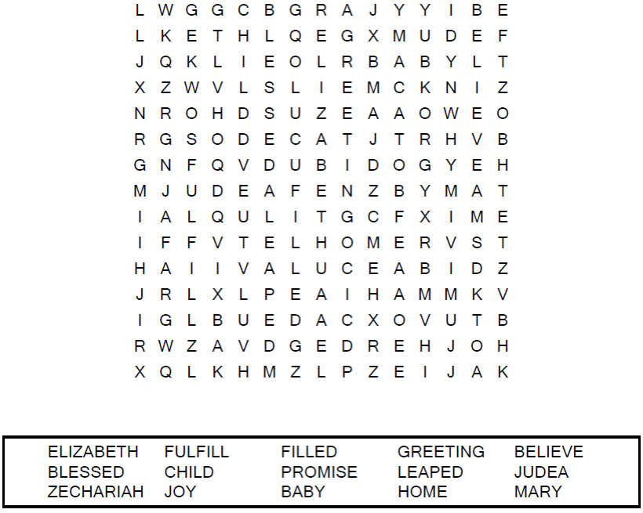

Your Church Name
City or Town

Decoder Puzzle
Each number represents a letter of the alphabet. Substitute
the correct letter for the numbers to reveal the coded words.
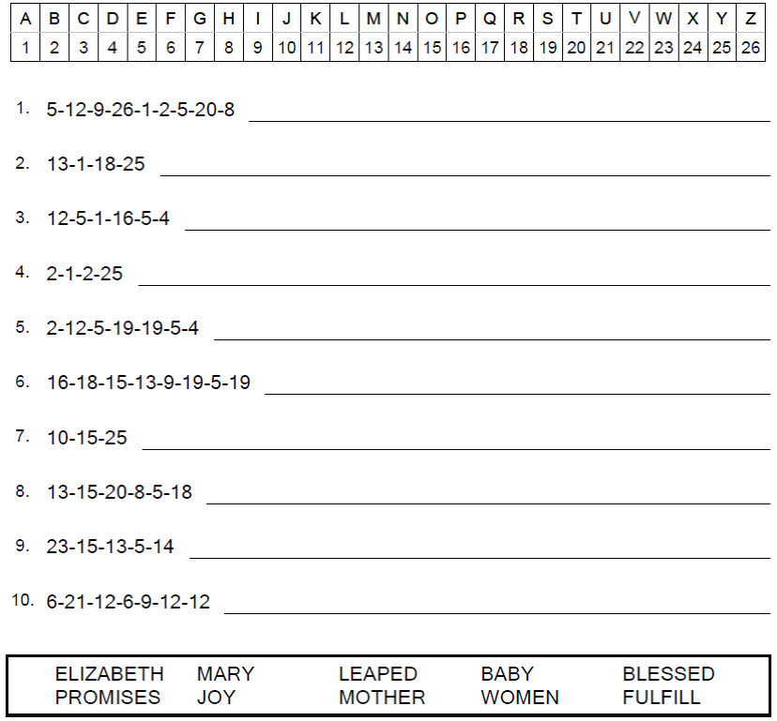
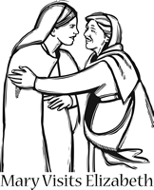

Coloring Page

