Crossword Puzzle

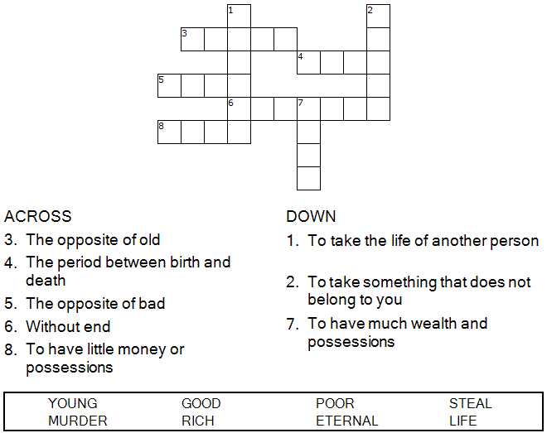

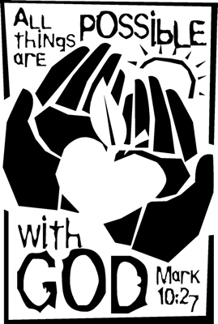

Copyright © Sermons4Kids, Inc.
May be reproduced for Ministry Use

Children’s Worship Bulletin



Mark 10:17-31

Word Search Puzzle

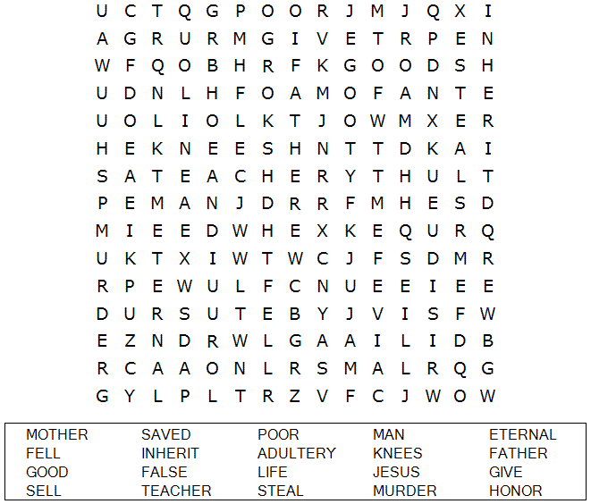

Your Church Name Here
Anytown, USA

Fill in the Blanks
Complete the sentences by filling in the blanks with the correct words from the word bank at the bottom of the page.
Check your answers in Mark 10:17-27 (NIV)

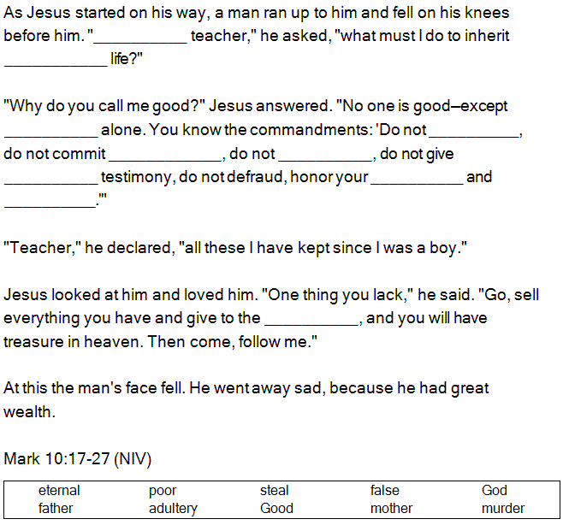
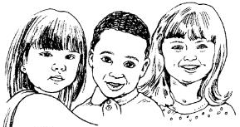

Decoder Puzzle
Each number represents a letter of the alphabet. Substitute the correct letter for the numbers
to reveal the coded words.

