Crossword Puzzle

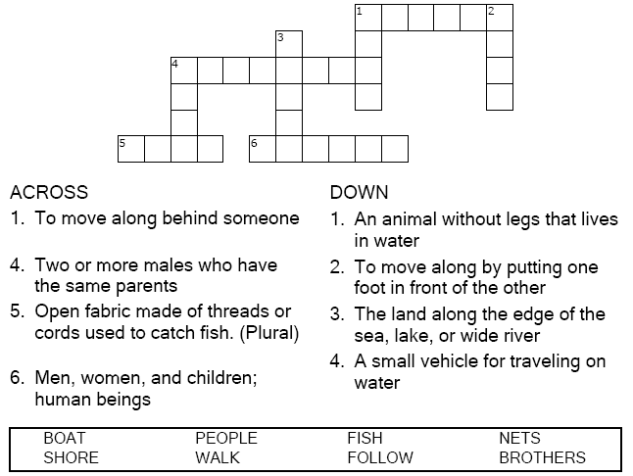



Copyright © Sermons4Kids, Inc.
May be reproduced for Ministry Use

Children’s Worship Bulletin



Matthew 4:18-22

Word Search

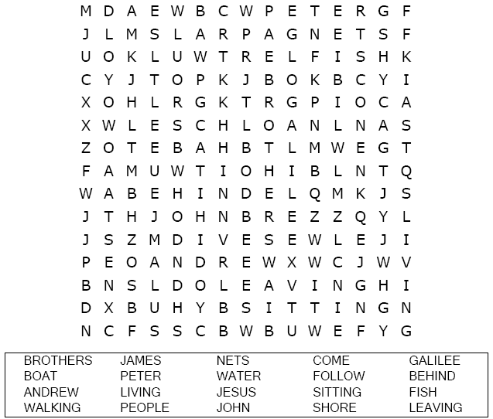
Your Church Name
City or Town

Coloring Page

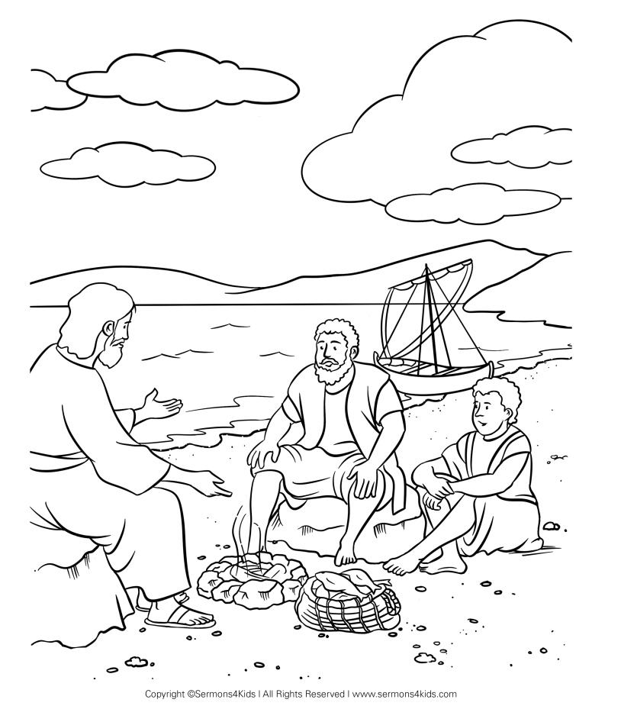

Jesus calls four of his disciples.

Connect the Dots

Connect the dots in ABC order to complete the picture.

Jesus called out to them, “Come, follow me, and I
will show you how to fish for people!”
Matthew 4:19 (NLT)

