Crossword Puzzle

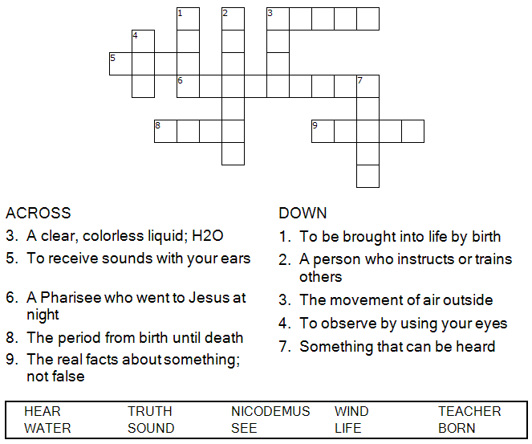



Copyright © Sermons4Kids, Inc.
May be reproduced for Ministry Use
Children’s Worship Bulletin



John 3:1-17

Word Search Puzzle

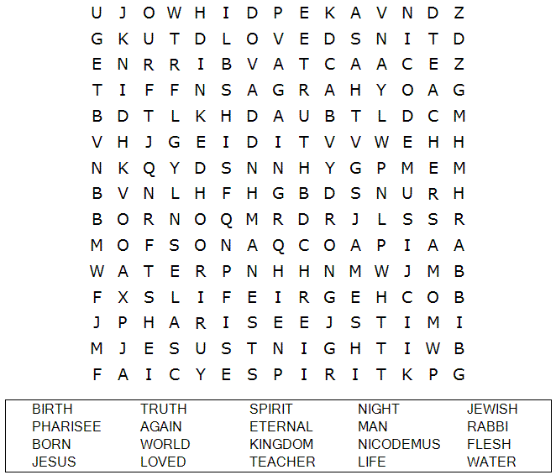

Your Church Name Here
Anytown, USA

Maze Puzzle
Can you help Nicodemus find his way to Jesus?

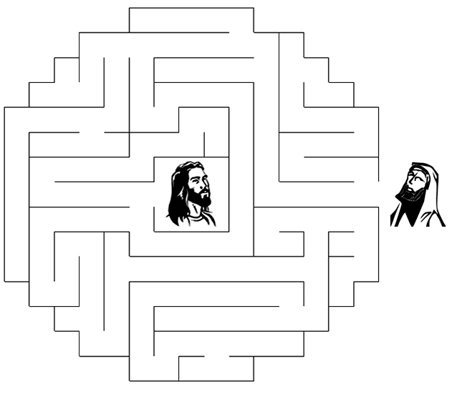

In reply Jesus declared, "I tell you the truth, no one can
see the kingdom of God unless he is born again."
John 3:3 (NIV)



Coloring Page



