Crossword Puzzle

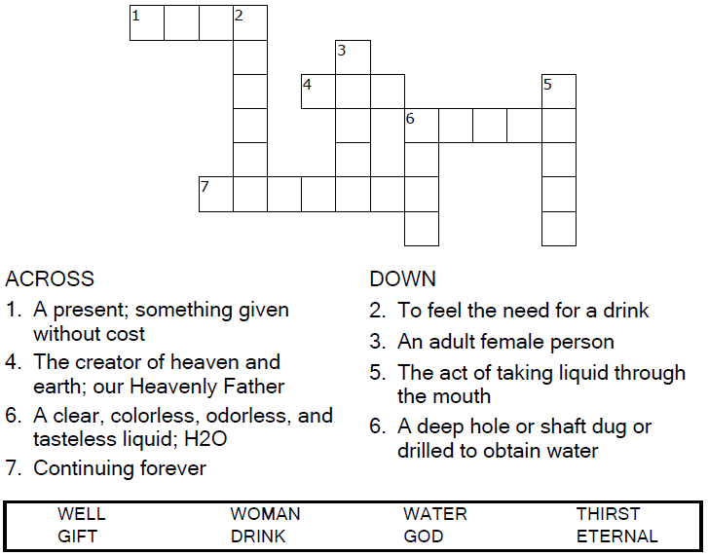
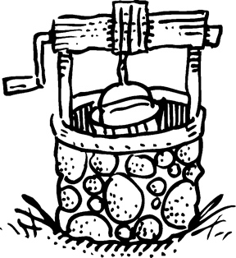

Copyright © Sermons4Kids, Inc.
May be reproduced for Ministry Use
Children’s Worship Bulletin



John 4:5-13

Word Search Puzzle
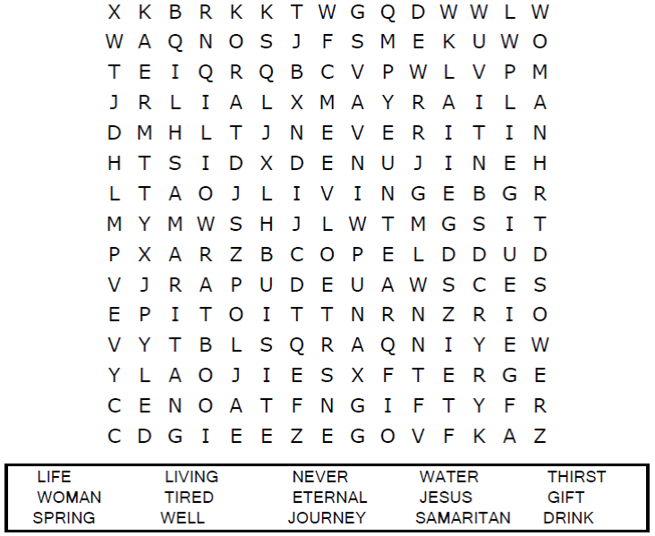



Coloring Page
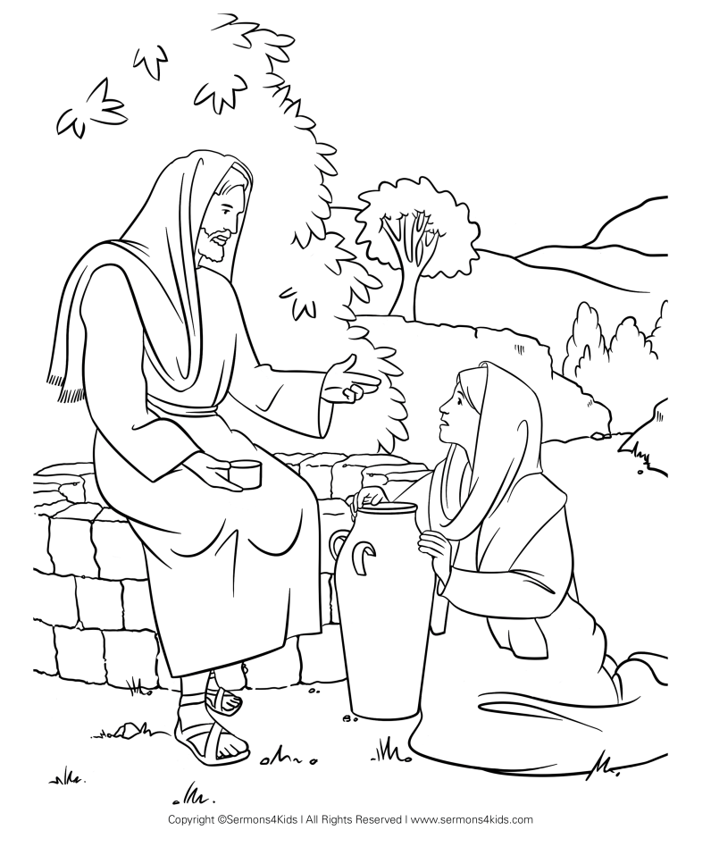

Help the Samaritan woman find the way to the well.
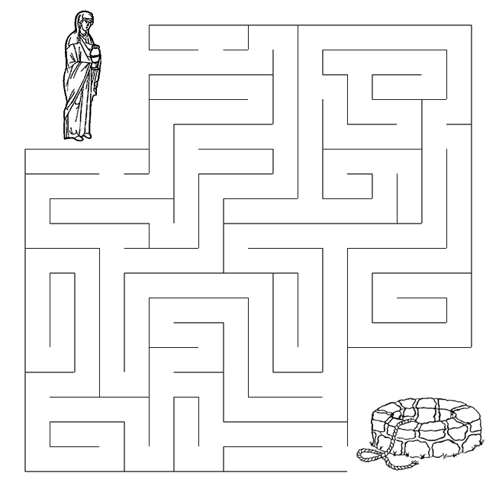
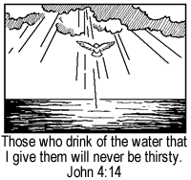

Maze Puzzle

