Crossword Puzzle

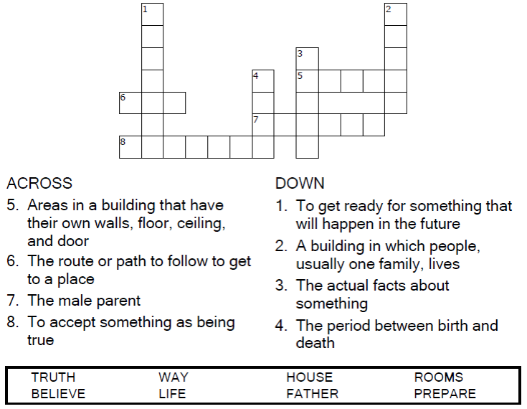
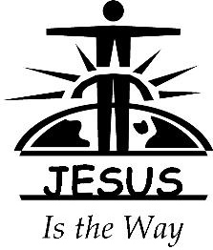

Copyright © Sermons4Kids, Inc.
May be reproduced for Ministry Use
Children’s Worship Bulletin



John 14:1-14

Word Search Puzzle

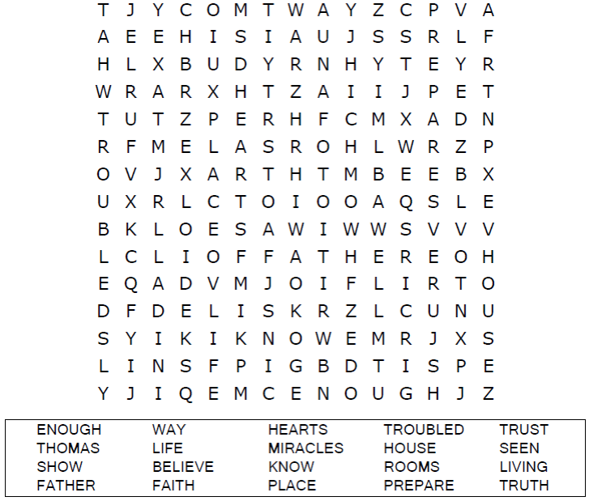

Coloring Page

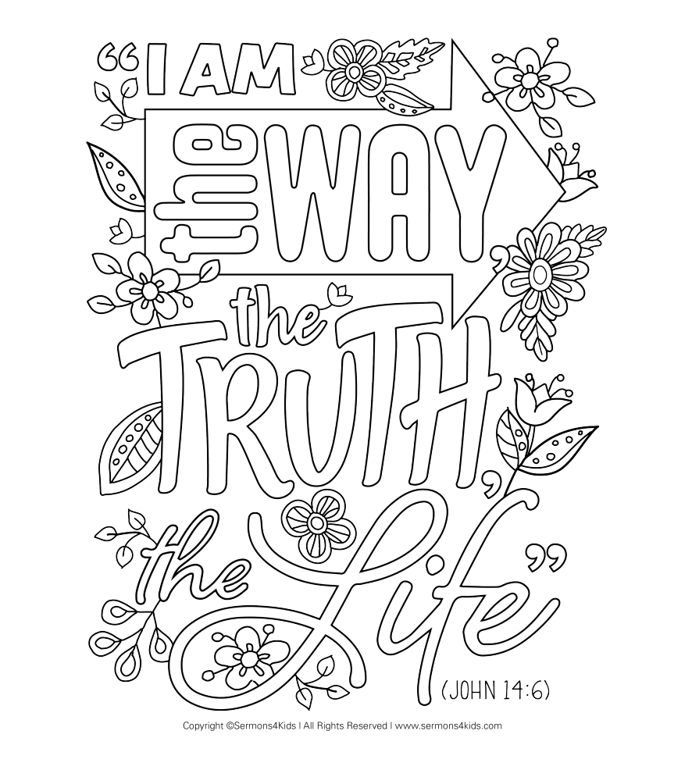

Maze Puzzle

