Crossword Puzzle

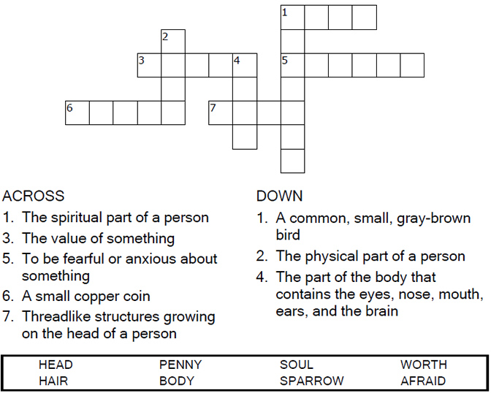
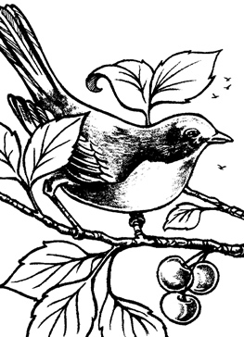

Copyright © Sermons4Kids, Inc.
May be reproduced for Ministry Use
Children’s Worship Bulletin



Mathew 10:24-33

Word Search Puzzle
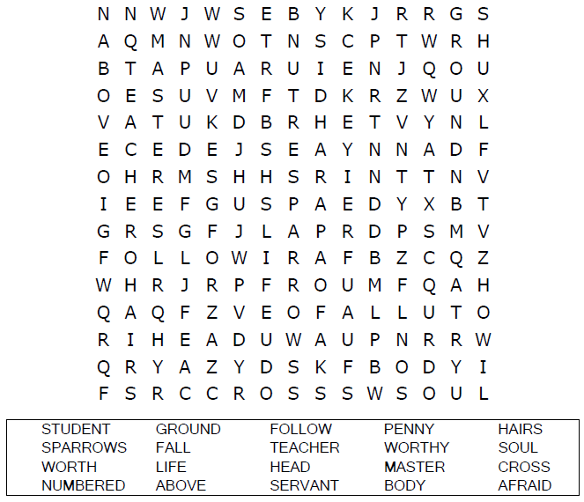
Your Church’s Name
Address
City, State

Coloring Page
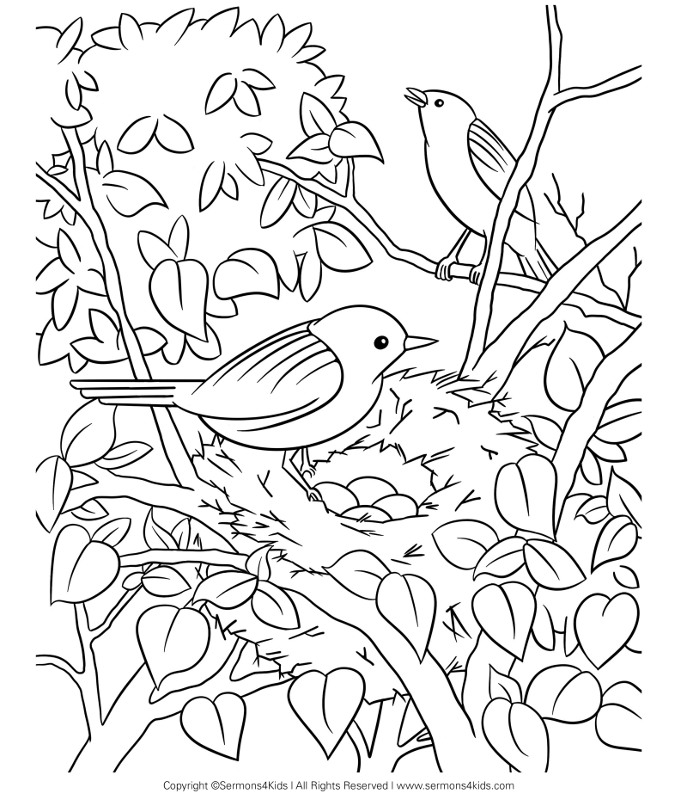
Jesus and the Children

Multiple Choice Quiz

Choose the word that best matches the definition.
Put the letter in the blank beside the definition.

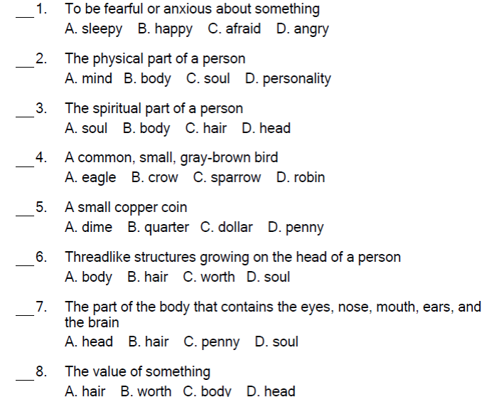


“So don’t be afraid; you are more valuable to God
than a whole flock of sparrows.”
Matthew 10:31

