Crossword Puzzle

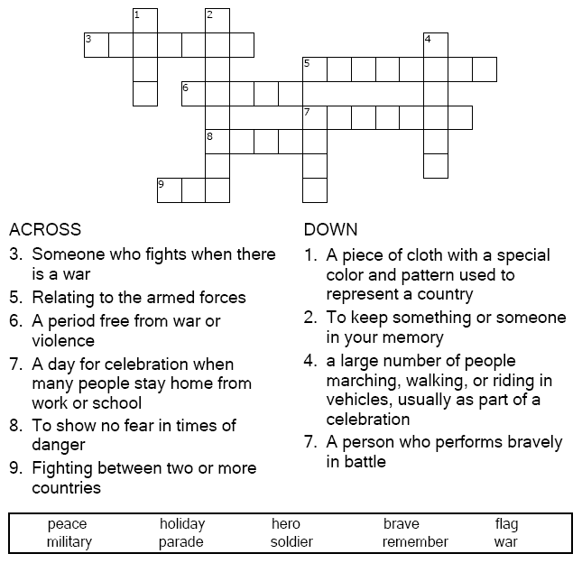

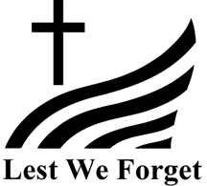

Copyright © Sermons4Kids, Inc.
May be reproduced for Ministry Use

Children’s Worship Bulletin



Luke 20:35-36

Word Search Puzzle

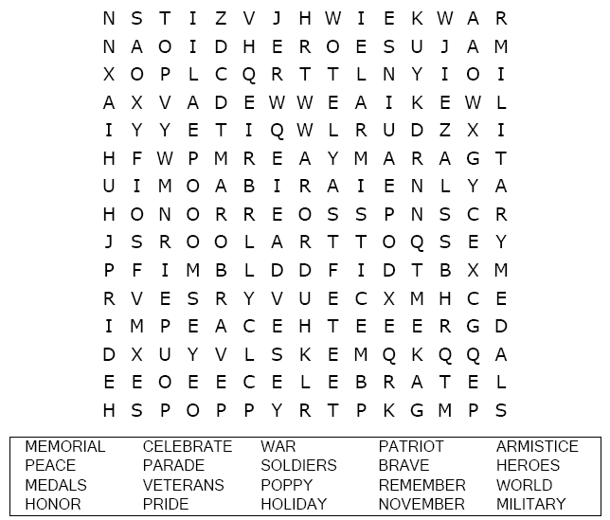

Your Church Name Here
Anytown, USA

Multiple Choice Quiz

Choose the word that best matches the definition.

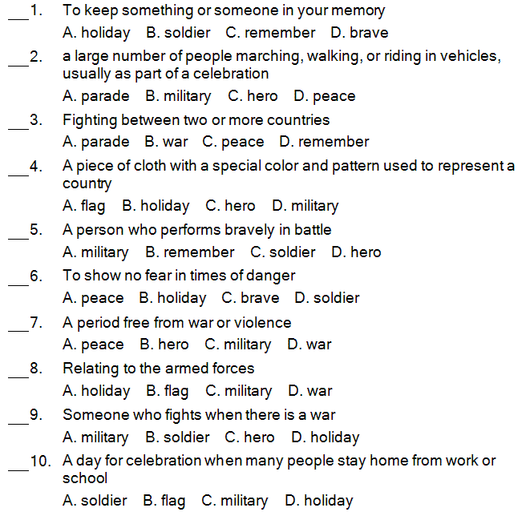

“The soldier, above all other people, prays for peace, for he must suffer and bear the deepest wounds and scars of war.”
Douglas MacArthur

Color Me!

