Crossword Puzzle
|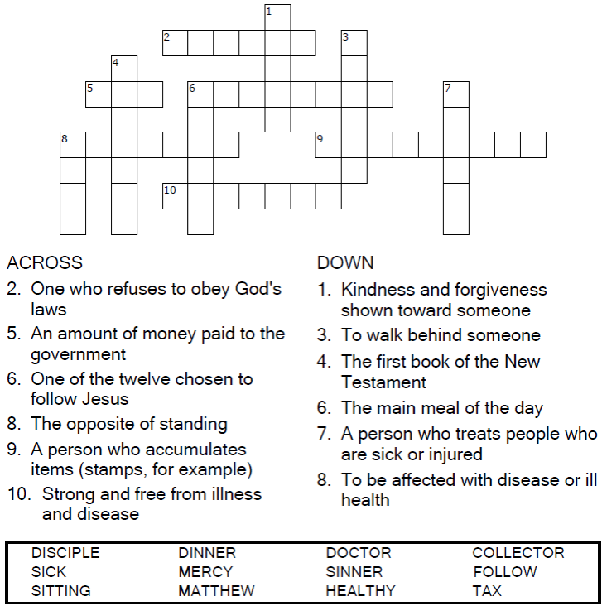

Copyright © Sermons4Kids, Inc.
May be reproduced for Ministry Use
Children’s Worship Bulletin



Matthew 9:12-13

Word Search

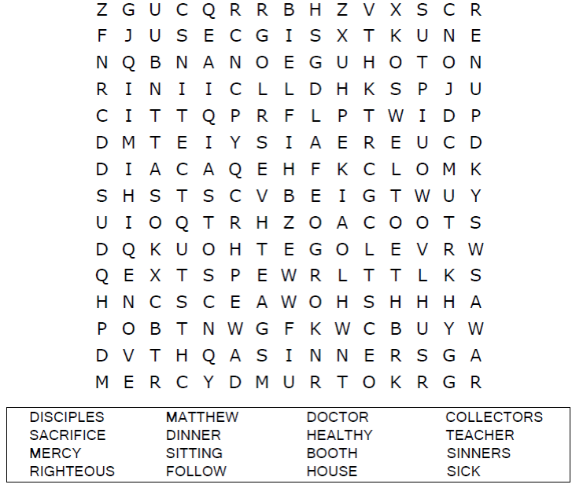
Your Church Name
City or Town

Multiple Choice
Enter the letter of the word that best fits the definition.
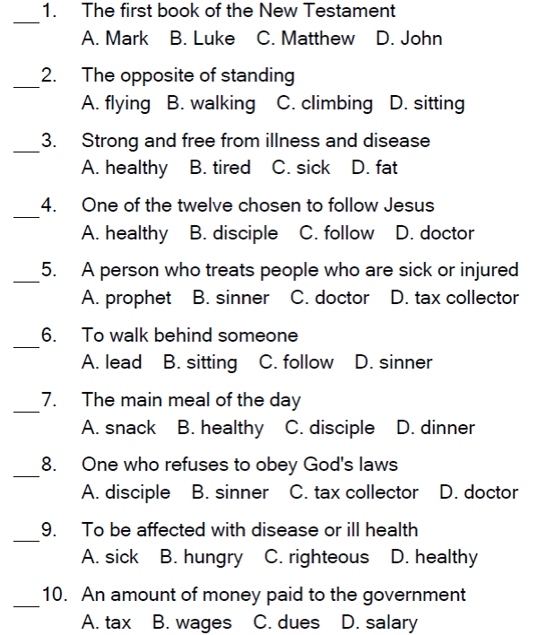

Coloring Page
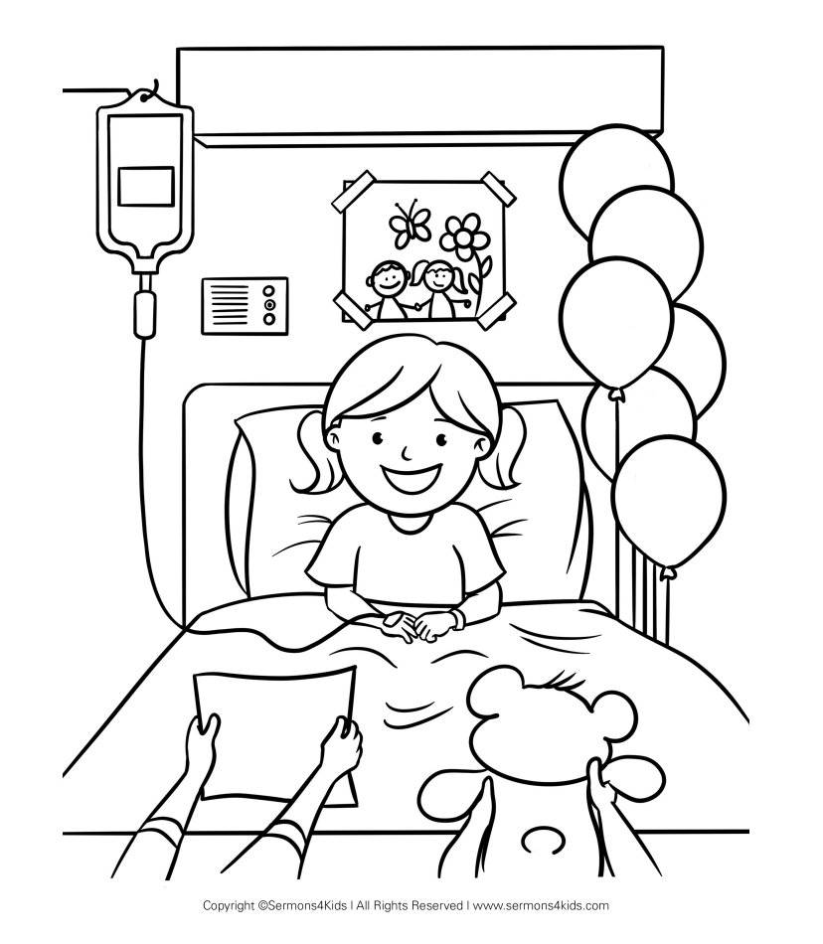

I can help sick people learn about Jesus.

