Crossword Puzzle

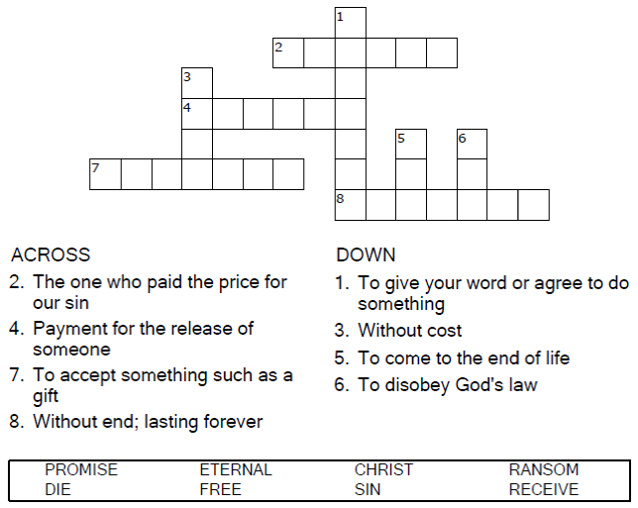


Copyright © Sermons4Kids, Inc.
May be reproduced for Ministry Use
Children’s Worship Bulletin



Hebrews 9:15

Word Search Puzzle

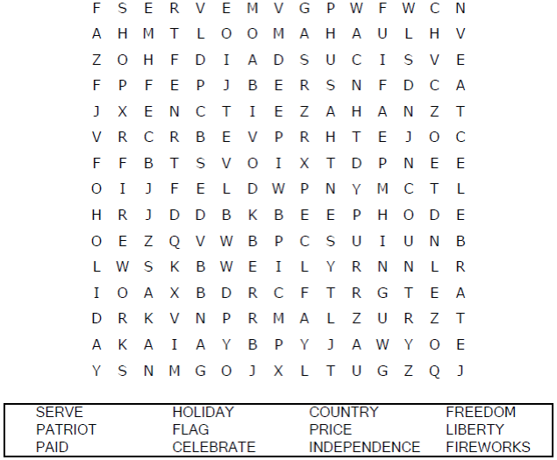

Coloring Page
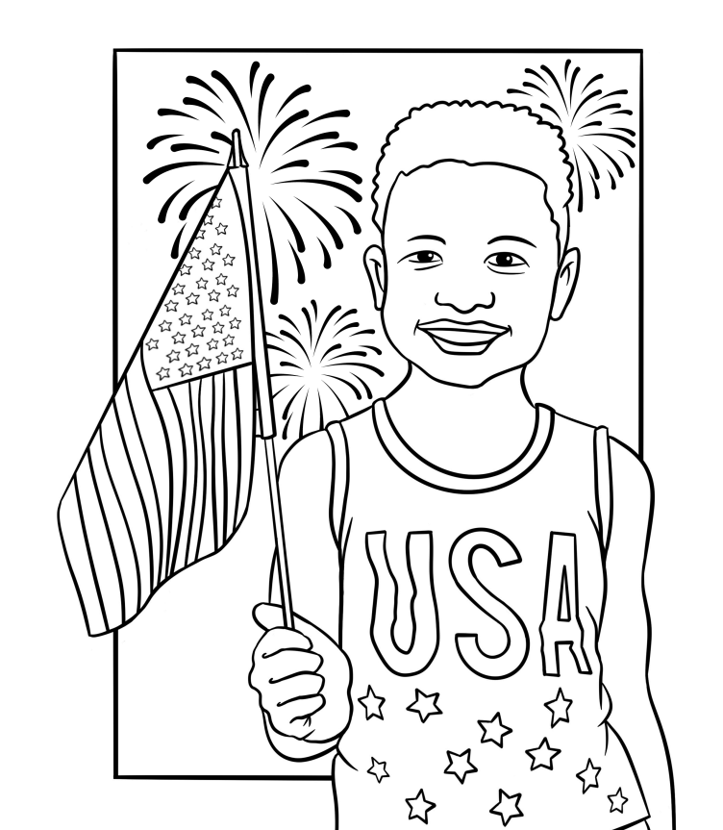
I can make others feel welcome by being friendly.



Decoder Puzzle

Each number represents a letter of the alphabet. Substitute
the correct letter for the numbers to reveal the coded words.

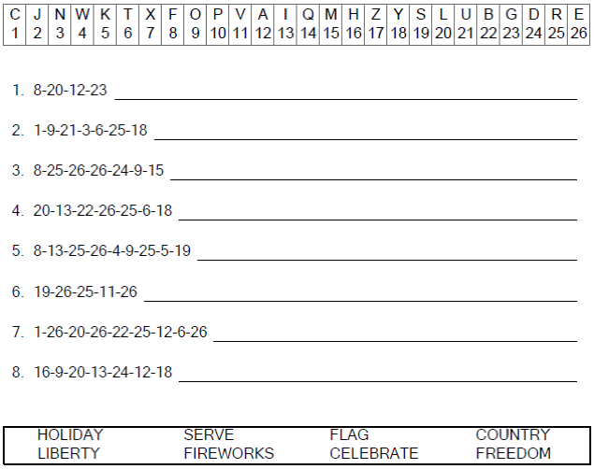


He died as a ransom to set them free from the sins committed under the first covenant.
Hebrews 9:15

