Crossword Puzzle

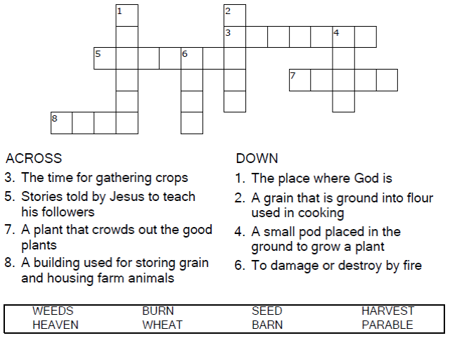


Copyright © Sermons4Kids, Inc.
May be reproduced for Ministry Use
Children’s Worship Bulletin



Matthew 13:24-29

Word Search Puzzle

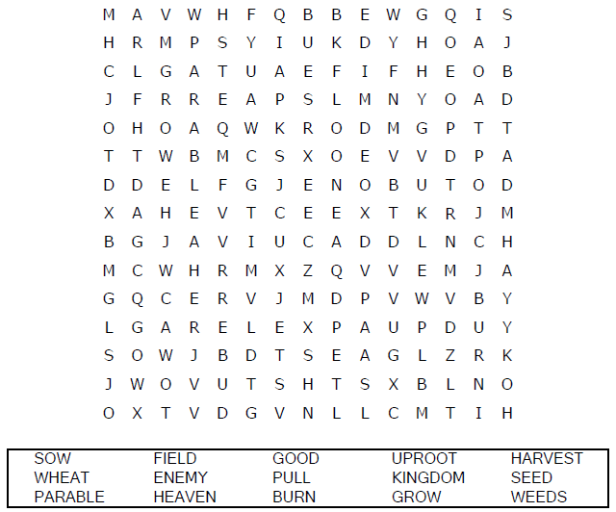

Coloring Page
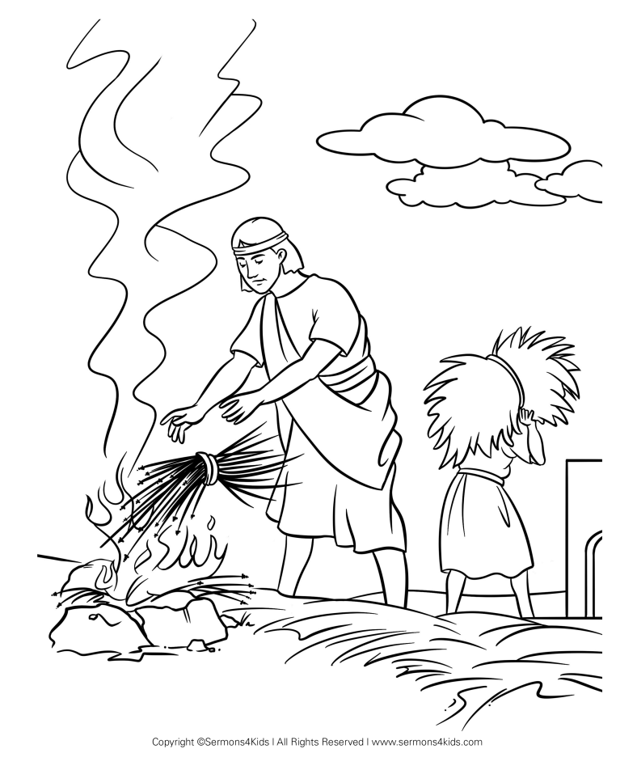
The Parable of the Weeds

Decoder Puzzle
Each number represents a letter of the alphabet.
Substitute the correct letter for the numbers
to reveal the coded words.

