Crossword Puzzle

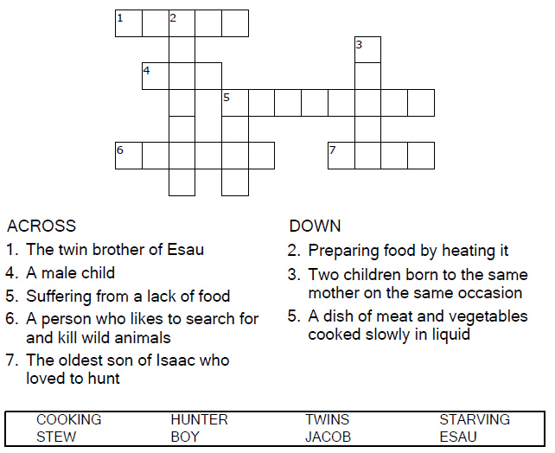
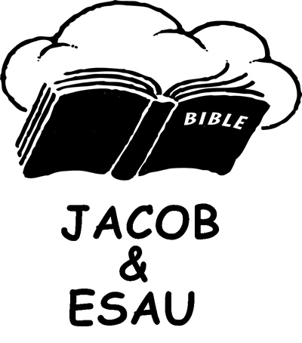

Copyright © Sermons4Kids, Inc.
May be reproduced for Ministry Use
Children’s Worship Bulletin



Genesis 25:19-34

Word Search Puzzle

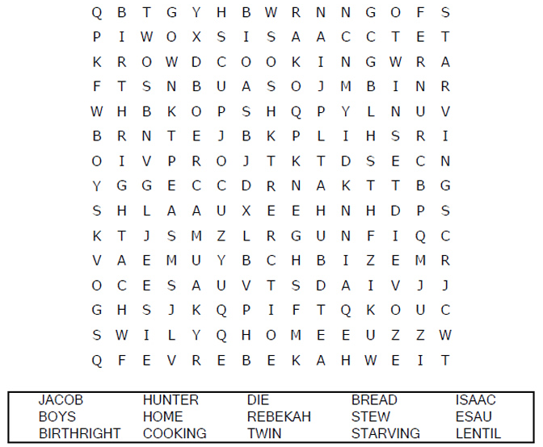
Your Church Name
Church Address
City

Coloring Page
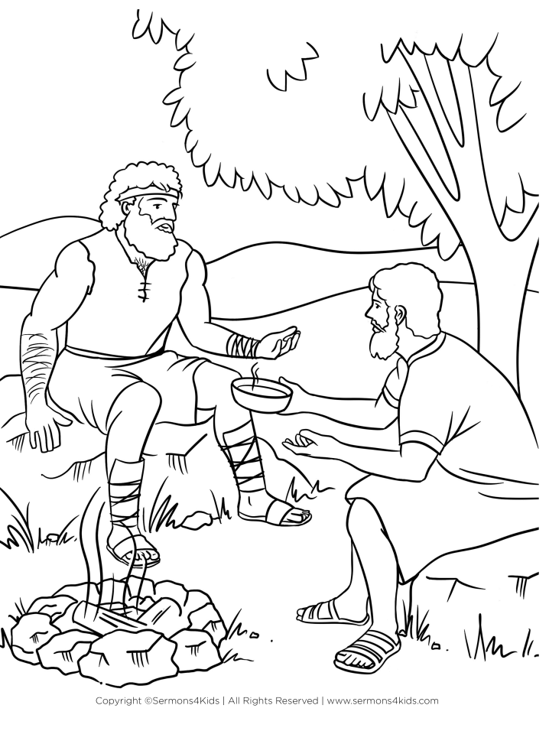
Esau Sells His Birthright to Jacob
Genesis 25:19-34

Decoder Puzzle

Each number represents a letter of the alphabet. Substitute
the correct letter for the numbers to reveal the coded words.

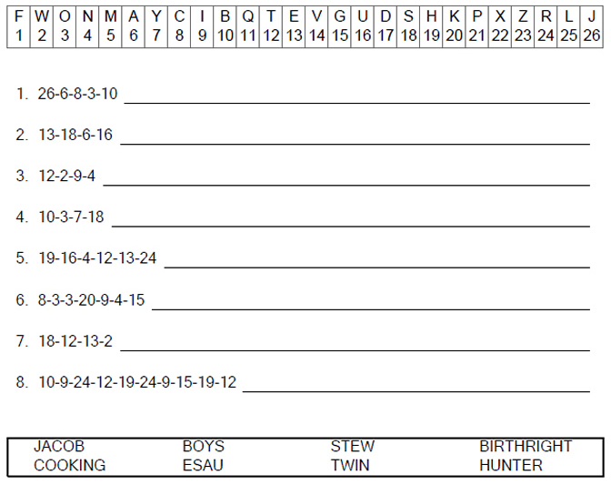

A birthright for a bow of stew!

