Crossword Puzzle

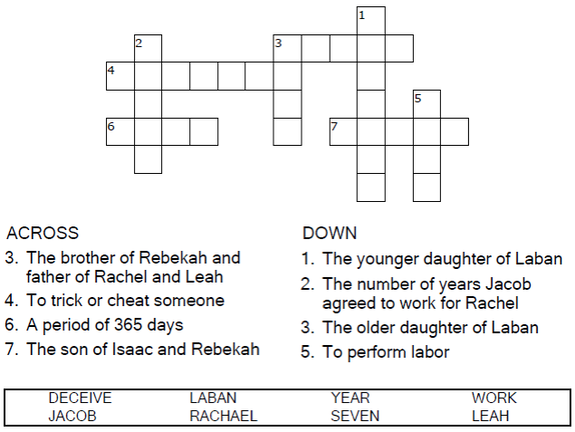
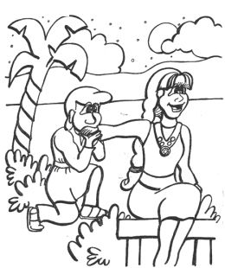

Copyright © Sermons4Kids, Inc.
May be reproduced for Ministry Use
Children’s Worship Bulletin



Genesis 29:15-28

Word Search Puzzle

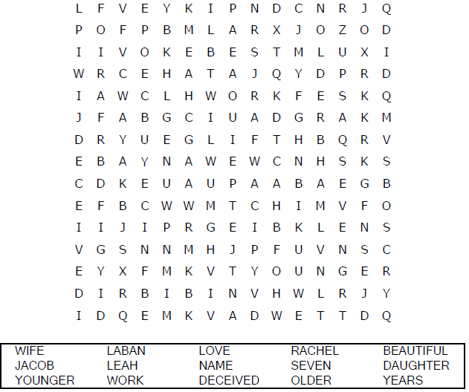
Church Name
Address
City

Coloring Page
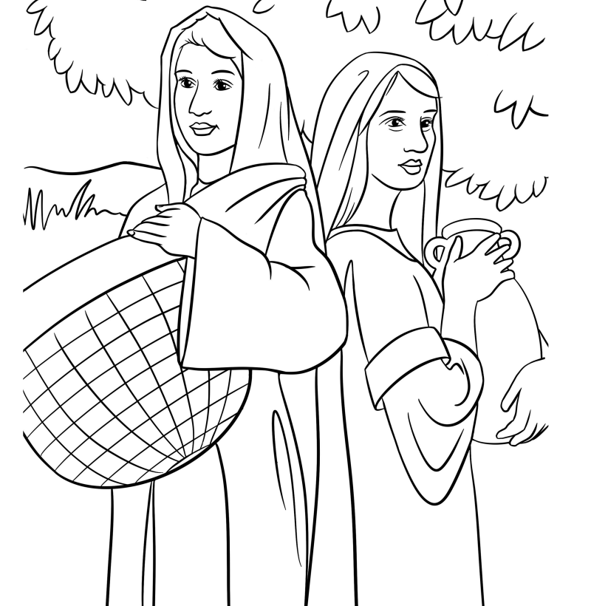
Leah and Rachel

Now Laban had two daughters; the name of the older was Leah,
and the name of the younger was Rachel.
Genesis 29:16

Decoder Puzzle

Each number represents a letter of the alphabet.
Substitute the correct letter for the numbers to
reveal the coded words.

