Crossword Puzzle

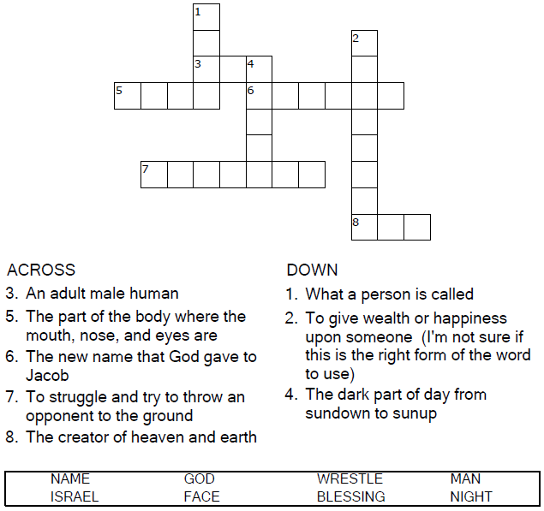


Copyright © Sermons4Kids, Inc.
May be reproduced for Ministry Use
Children’s Worship Bulletin



Genesis 32:22-31

Word Search Puzzle

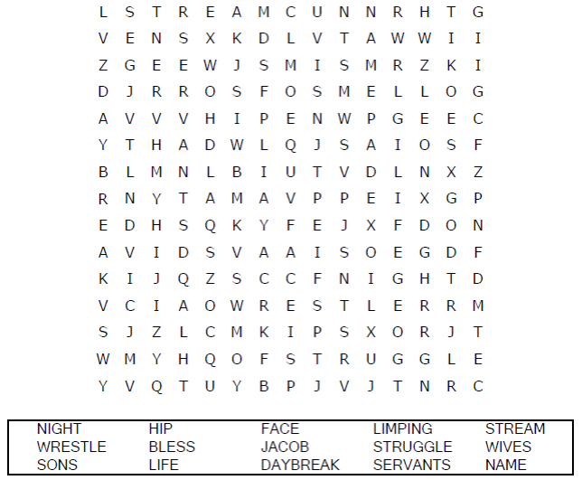
Church Name
Address
City

Coloring Page
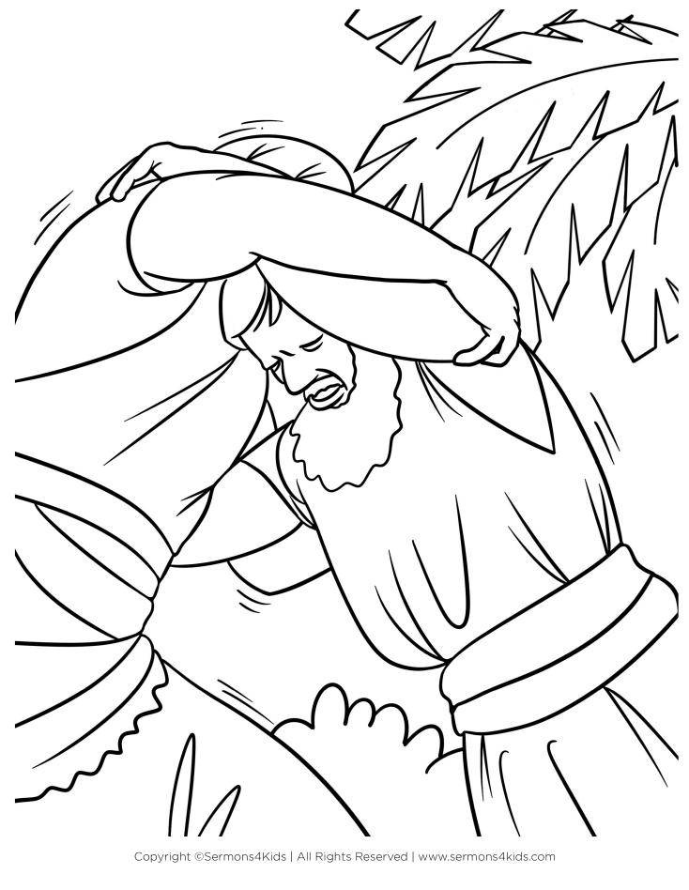
Your Name Shall Be Israel
Genesis 32:28

Decoder Puzzle
Each number represents a letter of the alphabet.
Substitute the correct letter for the numbers to
reveal the coded words.

