Crossword Puzzle

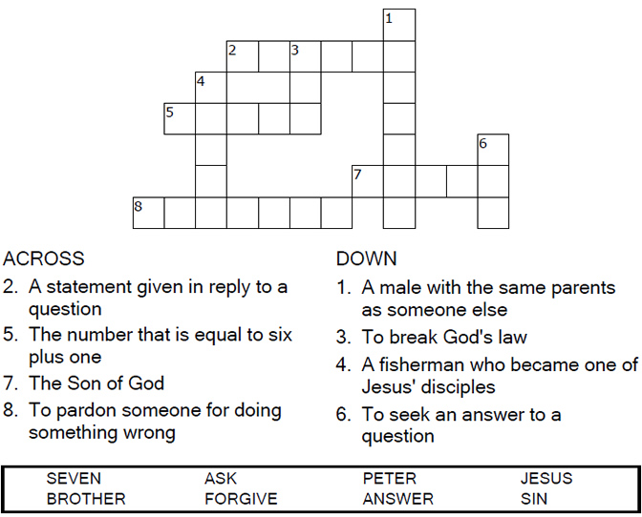


Copyright © Sermons4Kids, Inc.
May be reproduced for Ministry Use

Children’s Worship Bulletin



Matthew 18:21-35

Word Search Puzzle

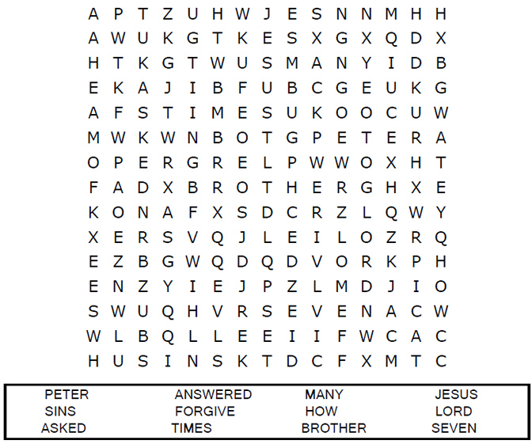
Your Church Name
Address
City

Coloring Page
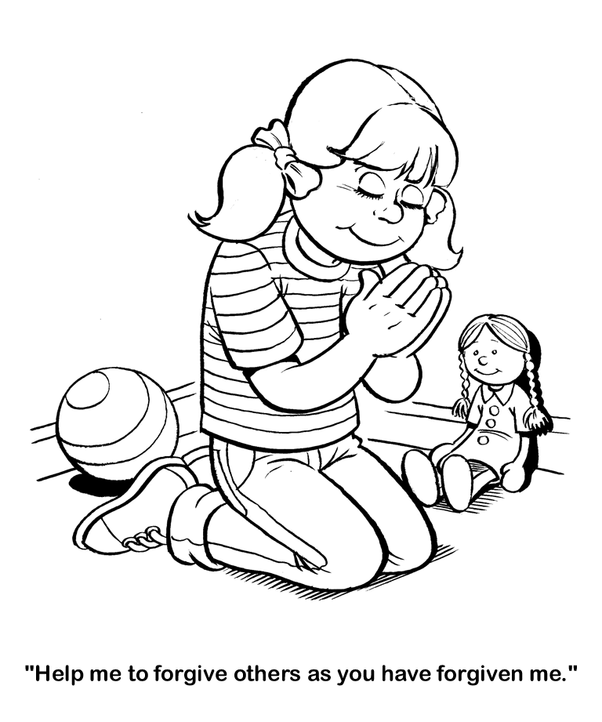

Decoder Puzzle

Each number represents a letter of the alphabet. Substitute
the correct letter for the numbers to reveal the coded words.

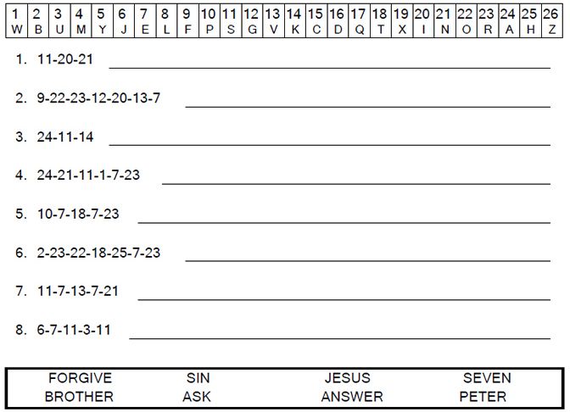
Then Peter came to Jesus and asked, "Lord, how many times shall I forgive my brother when he sins against me? Up to seven times?" Jesus answered, "I tell you, not seven times, but seventy-seven times. Matthew 18:20-22



