Crossword Puzzle

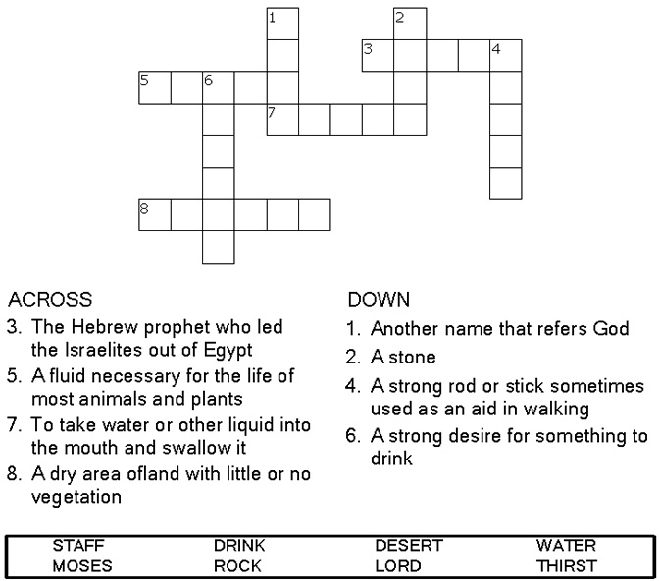

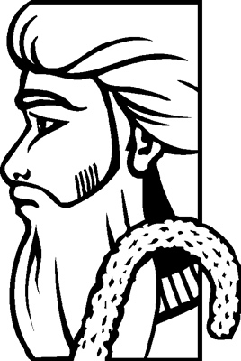

Copyright © Sermons4Kids, Inc.
May be reproduced for Ministry Use
Children’s Worship Bulletin



Exodus 17:1-7

Word Search Puzzle

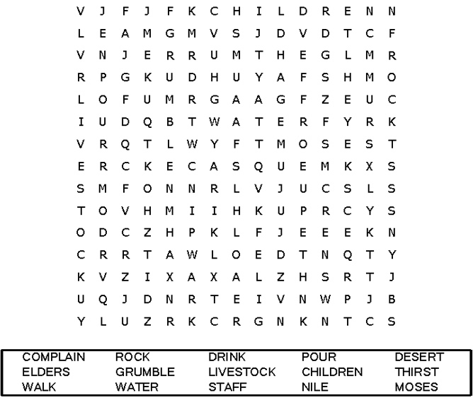
Your Church Name Here
Address

Decoder Puzzle
Each number represents a letter of the alphabet.
Substitute the correct letter for the numbers to
reveal the coded words.

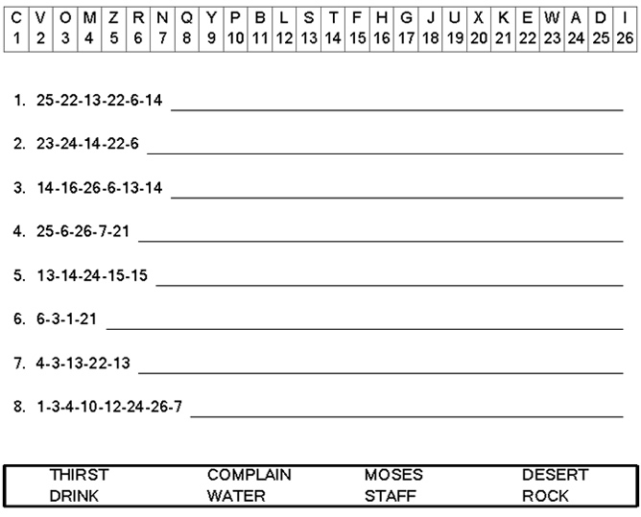
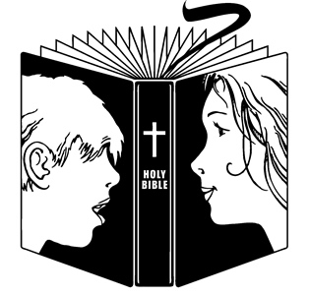

Coloring Page

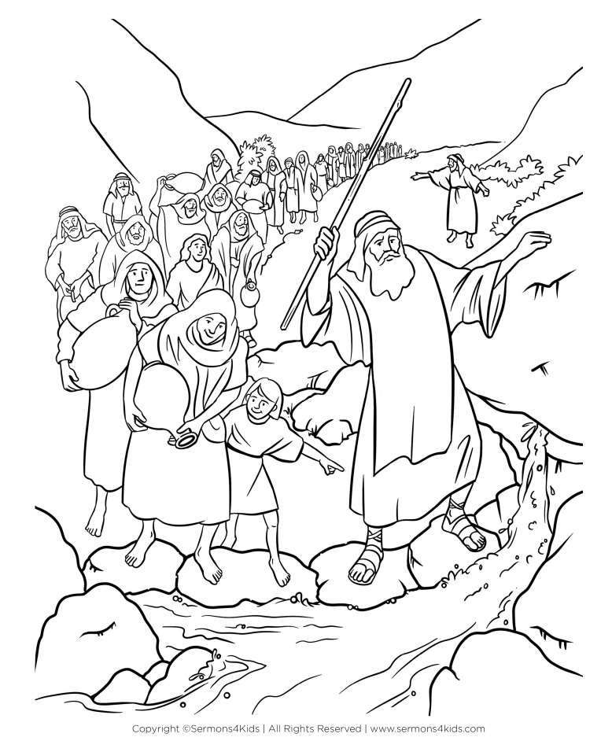
Moses Strikes the Rock
Exodus 17:1-7

