Maze Puzzle

You are invited to the wedding banquet!
Can you find your way to the wedding cake?
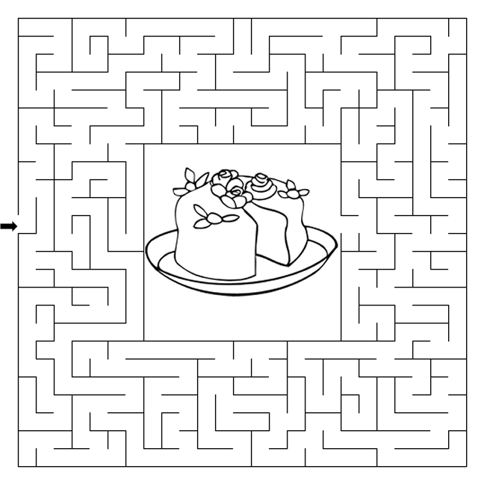

Copyright © Sermons4Kids, Inc.
May be reproduced for Ministry Use
Children’s Worship Bulletin



Matthew 22:1-14

Word Search Puzzle

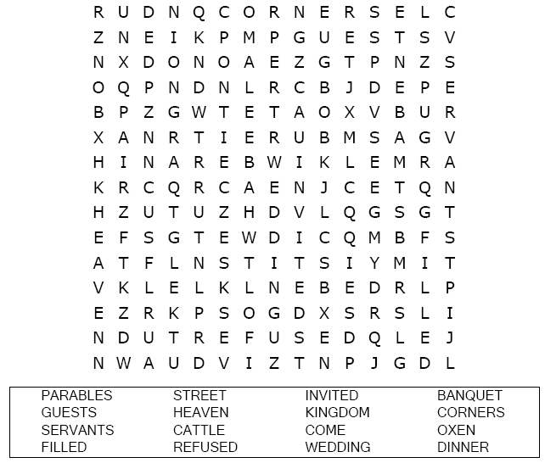
Your Church Name
Address
City

Coloring Page

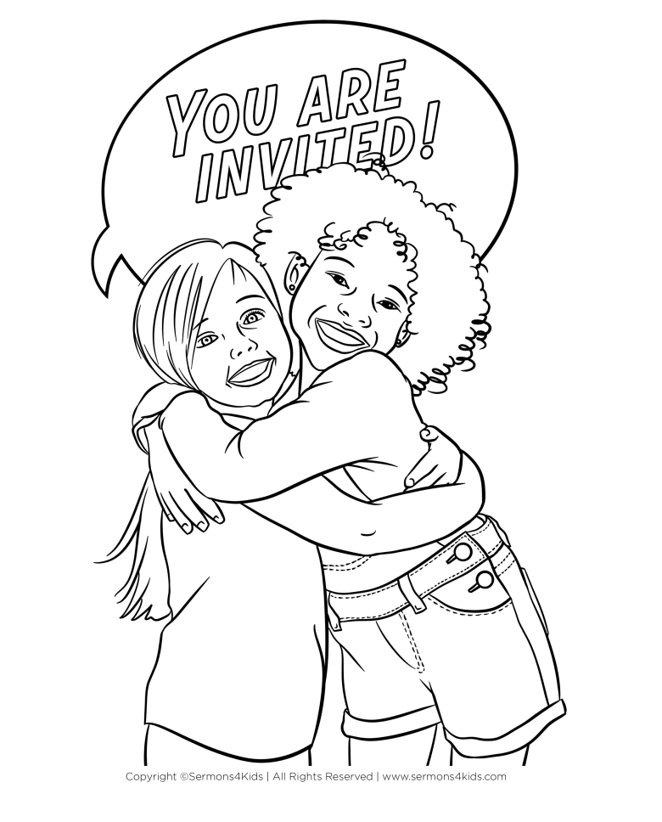
Inviting others to Jesus.

Decoder Puzzle

Each number represents a letter of the alphabet. Substitute
the correct letter for the numbers to reveal the coded words.

